

Optimization Frameworks for Hybrid Biomass Power-to-Methanol System: LP and Reinforcement Learning Approaches

Muhammad Rafi Afif Indrajaya

Erasmus Mundus Decentralized Smart Energy System (DENSYS)

Politecnico di Torino

Submitted on July, 18th 2026

Abstract
Hard-to-abate industries generate roughly 40% of global greenhouse gas emissions and present severe technical barriers to direct electrification, positioning synthetic e-fuels as a vital decarbonization alternative whose viability depends heavily on reducing high production costs. This thesis presents a two-phase techno-economic framework to optimize the sizing and operational dispatch of a hybrid biomass Power-to-Methanol (BPtMeOH) plant. In the first phase, monolithic Linear Programming (LP) co-optimization (Level 1) is benchmarked against a bi-level Bayesian Optimization and LP architecture (Level 2). Under realistic non-linear economies of scale, Level 2 achieved a superior Levelized Cost of Methanol (LCOM) of 761.2 $/ton compared to 779.0 $/ton from Level 1, demonstrating the advantage of decoupling sizing from dispatch in non-convex design spaces. In the second phase, an offline LP-derived ideal controller (IC) is compared against a Soft Actor-Critic (SAC) reinforcement learning agent across both an idealized fixed linear plant and high-fidelity environment with non-linear electrolyzer and hydrogen storage physics. On the linear system, the RL agent recovered 93.2% of the global optimal methanol yield under forecast uncertainty. However, deployment on the high-fidelity plant revealed the structural fragility of the offline linear schedule, demonstrating that simplified linear formulations yield overly optimistic techno-economic projections and that integrating higher-fidelity component physics is critical for viable dispatch.

Acknowledgment
I want to ddedicate this thesis for abladlkafjldkjfal flkad ladshflasdhf lasdkhfasd hflksadhflak hflkadhflkas dhflkasdh flkadshflkasdhflhadlsf hsadlf hadslfh lsadkh flskadhf lkasdhf ldkshf lksdahf lkdashf dss fsd fsdf sdf sdf sdfs df sdfaf asf asf asdf asdf as
Sd fasd fsadf
Fasdf asdf asf asd
Ds afda fsad f
D fas fasdf asdf
Dsf asdf adsf asdf
Df asdf asf
A dfasdf as
Sfsdfsdfadfasdfasdfadsfasdfasf
Dsfadsdfasd
Sdafdasf
Sdafasdf
Fsgsfgdsgsdfg
Dsfgfsgfsd
Gsdfgsdfgfsdgf
Sdfgsfdgsdfg
Sdfgsdfgsdf
Gsdfgsdfgsdf
gsdfgsdfgsdfgdsgdsfg
Table of Contents
1 Introduction 1
1.1 Background 1
1.2 Introduction to Company 2
1.3 Objective 2
1.4 Thesis Configuration 3
2 Literature Review 5
2.1 Power-to-X Integration for Methanol Synthesis System Error! Bookmark not defined.
2.2 MILP for Complex Polygeneration System 10
2.3 State-of-the-art RL in Optimizing Energy System and Industrial Processes 13
2.4 RL vs MILP for Different Applications 17
3 Methodology 20
3.1 Hybrid Biomass Power-to-Methanol System Model 20
3.2 Two-steps Outerloop & Innerloop Strategy 30
3.3 Level 2 Optimization Architecture (MILP) 23
3.4 Level 3 Optimization Architecture (RL) 26
3.5 Data 40
3.6 Comparison Stages & Scenario Definition Error! Bookmark not defined.
4 Results and Discussions 36
4.1 36
5 Conclusions 39
6 References 41

List of Abbreviations

Introduction

Background
The large-scale transformation of industrial energy systems is widely regarded as a critical enabler for achieving global decarbonization targets, particularly in so-called hard-to-abate sectors [1]. Among the available pathways, Power-to-X (PtX) technologies have emerged as a promising solution, enabling the conversion of renewable electricity into chemical energy carriers and synthetic fuels suitable for industrial applications [2]. However, PtX systems are inherently complex and capital-intensive, especially when their operation is coupled with the variability and intermittency of renewable energy source [3]. This complexity introduces significant challenges in both system design and operational planning, thereby necessitating robust optimization strategies that can effectively minimizing the levelized cost of the product.

To address this need, Mixed-Integer Linear Programming (MILP) has become the prevailing industrial standard due to its robustness, transparency, and well-established solution techniques [4]. At the same time, the rapid advancement of artificial intelligence (AI) has motivated the exploration of alternative methodologies, particularly reinforcement learning (RL) [5]. In this context, RL can be understood as an agent-based framework that learns optimal operational strategies through iterative interaction with the system environment, effectively acting as an autonomous plant operator.

Despite its widespread adoption, MILP relies on linear approximations of system behavior, which can limit model fidelity when representing inherently nonlinear processes [6]. In practice, such nonlinearities are often simplified or neglected. This limitation makes RL particularly attractive, as it allows for flexible environment design in which high-fidelity, nonlinear system dynamics can be directly incorporated. Through appropriately defined reward structures, the RL agent can learn operational strategies that account for these complexities without requiring explicit linearization [7].

In summary, this thesis evaluates the techno-economic performance of a reinforcement learning–based approach against a conventional MILP-based framework for a hybrid biomass power-to-methanol plant located in South Africa. The analysis is performed across multiple case studies to capture a range of varying operating conditions. Through this comparative assessment, the study seeks to clarify the role and current capabilities of RL in optimizing complex Power-to-X systems, while benchmarking its performance against an established industrial standard.

Introduction to Company
This master’s thesis is conducted in cooperation with FEV Europe GmbH, specifically within its energy+resources department. In this industrial context, the research aligns with ongoing efforts to expand capabilities beyond traditional automotive engineering toward energy-related applications. FEV Europe GmbH is widely recognized as an established expert within the automotive industry, particularly for its benchmarking and consulting services. Building on this foundation, the company is increasingly directing its efforts toward supporting innovation within the energy sector, reflecting broader industry trends and internal strategic priorities.

Within this framework, the present thesis contributes to the identification and evaluation of an efficient optimization tool for innovative energy solutions, with a focus on complex polygeneration plants. The outcomes are intended to support future FEV Europe GmbH projects by enabling improved system design and operational decision-making.

Objective
This thesis aims to systematically evaluate and compare two optimization frameworks across multiple operational scenarios. The analysis focuses on assessing their ability to represent and optimize complex hybrid energy systems, with particular attention to differences in system configuration and performance outcomes.

Building on this motivation, this thesis adopts a two-step methodological framework to systematically compare different levels of modeling fidelity and optimization approaches. In the first step, a comparison is conducted between a fully integrated MILP formulation and a decoupled framework in which system design (sizing) and operation (dispatch) are optimized separately. This step aims to assess the impact of incorporating nonlinear CAPEX assumptions in the outer-loop (design optimization). In the second step, the resulting optimal system sizing is used as an input for operational optimization, where both MILP and RL-based approaches are applied in the inner-loop (dispatch optimization). This structure enables a direct comparison of the two frameworks in terms of their ability to determine cost-optimal operational strategies, particularly when contrasting linearized system representations with higher-fidelity nonlinear models.

A central objective is to investigate whether a non-linear physical model integrated with a reinforcement learning (RL) agent converges to substantially different component sizing and system layouts compared to a mixed-integer linear programming (MILP) approach. These differences are examined in terms of key techno-economic indicators, including capital expenditure (CAPEX), operational expenditure (OPEX), clipped energy, simulation time, amount of methanol produced and levelized cost of methanol (LCOM).

Based on the simulation results, the thesis further aims to identify and explain the underlying reasons for any observed discrepancies—or the lack thereof—between the two frameworks. This comparative analysis supports a final assessment of whether one framework demonstrates superior performance or whether its suitability is dependent on specific system configurations and operating conditions.

The expected contribution of this work is to enable the selection of an appropriate optimization framework for hybrid methanol synthesis plants, while also providing a structured approach for framework selection in other industrial energy systems. Additionally, the findings aim to improve optimization accuracy and/or reduce computational effort, and to enhance understanding of where and how RL-based approaches can be effectively applied within polygeneration system design.

Thesis Configuration
This thesis is structured to provide a systematic and transparent comparison of the selected optimization frameworks. Chapter 2 reviews the state-of-the-art literature on the application of reinforcement learning (RL) in optimizing complex industrial processes and energy systems, including existing comparative studies between optimization approaches.

Chapter 3 details the methodological framework adopted for the comparison. It outlines a multi-stage evaluation procedure, describing each step taken to ensure a consistent and rigorous assessment of the two optimization approaches.

Chapter 4 presents and discusses the results of this multi-stage comparison. It analyzes the performance of each framework across different scenarios and case studies, and introduces a generalization scoring approach to assess their robustness and applicability across multiple evaluation dimensions.

Finally, Chapter 5 summarizes the main findings of the thesis and reflects on key limitations, assumptions, and methodological considerations that underpin the analysis, providing context for the interpretation and transferability of the results.

Literature Review

Hybrid Biomass Power-to-Methanol System
The hybridization strategy considered in this thesis integrates two upstream pathways that jointly supply the feedstock for methanol synthesis: (i) a biomass-derived pathway and (ii) a hydrogen pathway based on water electrolysis. This configuration enables coordinated carbon and hydrogen management prior to the synthesis loop. In the literature, gasification is most commonly employed to directly convert solid biomass into syngas. An alternative route relies on anaerobic digestion (AD), where biomass is first converted into biogas and then reformed to syngas prior to methanol synthesis. The differences in process steps primarily drive the trade-offs between these technologies. The AD-based route is attractive because it can be integrated with existing waste-treatment infrastructure; however, it requires additional downstream conversion steps, making the pathway less direct and more dependent on reforming, CO₂ handling, and potentially electrolysis integration. In contrast, gasifier-based routes are more established for methanol synthesis, as they provide syngas directly and are well suited for coupling with high-temperature processes. Their disadvantages include challenges related to high-temperature solid handling, the requirement for an oxygen supply (e.g., via an air separation unit, ASU), and stricter gas-cleaning requirements [8].
Table 1 Structural and Process Comparison between AD and Gasification routes
Metric | Anaerobic Digestion (AD) Route | Biomass Gasification Route | References
Primary Conversion Mechanism | Biochemical (mesophilic/thermophilic digestion of wet organic feedstocks) | Thermochemical high-temperature reactions ($>{800}^{∘}\text{C}-{1200}^{∘}\text{C}$) | [9]
Intermediate Stream | Biogas ($∼55\text{--}65\% {\text{CH}}_{4}$, $35\text{--}45\% {\text{CO}}_{2}$) requiring reforming to form syngas. | Raw syngas ($\text{CO},{\text{H}}_{2},{\text{CO}}_{2},{\text{CH}}_{4}$) containing tars and particulates. | [9], [10]
Feedstock Flexibility | High-moisture, biodegradable substrates (e.g., sewage sludge, organic municipal solid waste, agricultural slurry). | Low-moisture solid biomass (e.g., forestry residues, lignocellulosic crop waste, refuse-derived fuel/RDF). | [9]
Core Process Bottleneck | Biogas reforming (Dry Reforming DRM / Steam Reforming SMR) and stoichiometric ${\text{H}}_{2}/\text{CO}$ ratio adjustment. | Severe syngas conditioning requirements (tar removal, particulate scrubbing, sulfur/halogen cleanup, and Water-Gas Shift). | [9], [11]
Techno-Economic Profile | Lower CAPEX per unit capacity; economically viable at smaller, regional plant sizes. | High upfront CAPEX; strongly dependent on economies of scale and centralized feedstock supply chains. | [10]
Lifecycle GHG Abatement | Moderate-to-high carbon footprint reduction depending on feedstock cultivation and digestate handling. | Exceptional carbon abatement potential (up to $-0.88 {\text{t CO}}_{2}{\text{e/t CH}}_{3}\text{OH}$) when combined with biogenic carbon capture. | [10]

The hydrogen pathway begins with the electrochemical splitting of water into hydrogen and oxygen using an electrolyzer.
$$2{\text{H}}_{2}\text{O}→2{\text{H}}_{2}+{\text{O}}_{2}$$
Equation 1 Electrolysis.
Several studies identify Solid Oxide Electrolyzer Cells (SOECs) as a promising option for power-to-methanol systems. The high operating temperature of SOECs allows for heat integration and potential oxygen utilization, which can increase overall plant efficiency compared to low-temperature systems[12]. However, key challenges include long-term stack durability, technological maturity, and limited operational flexibility, which is particularly relevant for systems coupled to variable renewable electricity. Techno-economic comparisons suggest that alkaline water electrolysis (AWE) represents a viable short- to mid-term option, whereas SOECs are more likely to be competitive in the mid- to long-term. Low-temperature electrolyzers such as AWE and proton exchange membrane (PEM) systems offer higher technological maturity and superior load-following capability, which is advantageous for renewable integration, but they do not fully exploit heat integration or co-electrolysis opportunities available to SOECs [13]. A detailed quantitative synthesis of these performance metrics and operating limits is summarized in Table 2.
Table 2 Parameter comparison between AWE, PEM, and SOEC [14], [15], [16].
Parameter | Alkaline Water Electrolysis (AWE) | Proton Exchange Membrane (PEM) | Solid Oxide Electrolysis (SOEC)
Operating Temperature (${}_{​}^{∘}{\text{C}}$) | $$60-{90}^{∘}\text{C}$$ | $$50-{80}^{∘}\text{C}$$ | $$650-{1000}^{∘}\text{C}$$
Operating Pressure ($\text{bar}$) | $$<30\text{ bar}$$ | $$30-80\text{ bar}$$ | $$<30\text{ bar}$$
Energy Consumption (${\text{kWh/Nm}}^{3} {\text{H}}_{2}$) | $$4.5-5.5$$ | $$4.2-5.5$$ | $$3.2-3.8$$
Minimum Operational Load ($\%P_{\text{nom}}$) | $$10\%-20\%$$ | $$0\%-10\%$$ | $$20\%-30\%$$
Dynamic Response | Moderate ($0.2\text{--}20\%/\text{s}$) | Very High ($10\text{--}100\%/\text{s}$) | Low ($<1\%/\text{s}$)
${\text{H}}_{2}$ Purity ($\%$) | $$>99.5\%$$ | $$>99.999\%$$ | $$>99.9\%$$
Commercial Status / TRL | Commercial / State-of-the-art (TRL 9) | Near-commercial (TRL 8-9) | R&D (TRL 6-7)

In hybrid biomass and power-to-methanol (PBtM) systems, the technical consensus across recent literature emphasizes the need to achieve an optimal blending between the carbon-rich syngas with the pure hydrogen coming from the electrolyzer to achieve complete carbon efficiency [17]. Three repeating strategies are used in the literature for this specific goal:

- Direct hydrogen blending upstream of methanol loop compressor:
Biogas goes through a reformer to produce a primary syngas containing CO, CO₂, and H₂. Due to the low stoichiometric module below the required threshold of around 1.5 – 1.8, the blending with hydrogen before the methanol reactor increases this number to >2, enabling 100% biogenic carbon recovery without venting CO₂ [18].

- Reverse Water-Gas Shift (RWGS) Coupling Junction:
Unrefined or partially reformed biogas CO2 is routed into an RWGS reactor
$${\text{CO}}_{2}+{\text{H}}_{2}⇌\text{CO}+{\text{H}}_{2}\text{O}$$
Equation 2 RWGS chemical reaction.
Where it explicitly mixes with a portion of the green hydrogen stream at $600-{800}^{∘}\text{C}$. Direct CO₂ hydrogenation to methanol produces one mole of water for every mole of methanol,
$${\text{CO}}_{2}+3{\text{H}}_{2}⇌{\text{CH}}_{3}\text{OH}+{\text{H}}_{2}\text{O}$$
Equation 3 CO2- based Methanol synthesis.
which accelerates catalyst deactivation through kinetic inhibition and active site sintering [17]. By meeting in an RWGS unit prior to the methanol synthesis, the hydrogen reduces CO₂ to CO, shifting the synthesis reaction toward the faster, more thermodynamically favorable CO hydrogenation route [19].
$$\text{CO}+2{\text{H}}_{2}⇌{\text{CH}}_{3}\text{OH}$$
Equation 4 CO-based Methanol synthesis.

- Anodic Oxygen Integration at the Reforming Stage:
In this strategy, the byproduct of the electrolysis step, O₂, already meets the biogas path inside an Autothermal Reformer (ATR). The oxygen from the electrolyzer will then be used to generate internal thermal energy via exothermic methane partial oxidation
$$2{\text{CH}}_{4}+{\text{O}}_{2}+{\text{H}}_{2}\text{O}→2\text{CO}+5{\text{H}}_{2}$$
Equation 5 ATR checmical reaction.
Which sustains the endothermic steam reforming reactions. This strategy eliminates the need for a capital-intensive Air Separation Unit (ASU). Dossow et al. [20] demonstrated that full oxygen integration between water electrolysis and thermochemical reforming reduces overall auxiliary plant electrical consumption by 8-12%, establishing a closed mass-and-energy synergy between the hydrogen and biogas paths.

While these strategies establish the thermodynamic and chemical validity of stream integration, maintaining mass-balance ratios between the continuous biogas path and volatile power-dependent hydrogen path remains a central operational dispatch challenge requiring advanced optimization strategies [21].

The hybrid approach to methanol production is attractive due to its potential for higher carbon utilization and improved use of biomass resources. One study reports a carbon utilization of 89.8% and an overall efficiency of 85.8%, with up to 101% higher methanol production per unit of biomass compared to a conventional biomass-to-methanol baseline [22]. Another analysis indicates that a state-of-the-art biomass-to-methanol process achieves approximately 53.3% efficiency with a 4.8-year payback period, while integrating electrolysis for full carbon conversion increases efficiency to 64.5–66.0%, albeit with less favorable economics [23]. Furthermore, under favorable electricity price conditions, flexible operation can allow the plant to capture value from temporal price variations instead of operating continuously at a fixed load [24].

Despite these advantages, several bottlenecks challenge the feasibility of hybrid methanol systems. These include electrolyzer utilization rates, electricity price volatility, capital cost and lifetime of electrolyzer stacks, as well as the integration of oxygen and heat streams. For example, it has been reported that high electrolyzer capacity factors are required for competitive e-methanol production, and that full-carbon-conversion configurations become attractive only when improvements in electricity costs, stack lifetime, and capital expenditure are realized [25]. Oxygen management represents an additional practical constraint: while direct integration of oxygen streams may reduce the need for large-scale oxygen storage and improve capital efficiency and safety, this is contingent on matching oxygen supply and demand within the plant [21].

To address these challenges, process and system-level optimization emerges as a critical tool for improving both technical and economic performance. For instance, optimization of the methanol synthesis reactor in a power-and-biomass-to-methanol (PBtM) configuration has been shown to reduce e-methanol production costs by approximately 20% [25]. While such studies typically focus on individual subsystems, it is reasonable to expect that plant-wide optimization could yield further cost reductions and efficiency gains. In this context, optimization acts as the bridge between technically feasible system designs and configurations that remain viable under realistic operating conditions, including fluctuating electricity prices, electrolyzer degradation, and large-scale capital constraints.

MILP for Complex Polygeneration System
MILP, or Mixed-Integer Linear Programming, has been used as a tool to optimize different kinds of energy or industrial plants by linearizing the model of these processes and setting up a linear objective function to either maximize or minimize specific key performance indices (KPIs) based on the optimization objective [26]. In an energy system that includes the flow of electricity, heat, and mass, the constraints considered will then dictate how the balance of the system should behave, the minimum and maximum operational dispatch, and the evolution of the storage state of charge, if storage exists. On the other hand, the objective function mainly includes the capital expenditure (CAPEX) and operational expenditure (OPEX) of the models defined in the system.

$$\min{Z}=\sum_{c∈C}{\left[{\text{CAPEX}}_{c}⋅\left(\frac{r{\left(1+r\right)}^{n_{c}}}{{\left(1+r\right)}^{n_{c}}-1}\right)+{\text{OPEX}}_{\text{fix},c}\right]}+\sum_{t=1}^{T}{\left(C_{\text{electricity}}\left(t\right)+C_{\text{feedstock}}\left(t\right)+C_{\text{var}}\left(t\right)\right)}⋅Δt$$
Equation 6 Objective function example of an energy system
$$\sum_{g∈G}{P_{g}}\left(t\right)+P_{\text{grid, buy}}\left(t\right)+P_{\text{bat, dis}}\left(t\right)=P_{\text{demand}}\left(t\right)+P_{\text{grid, sell}}\left(t\right)+P_{\text{bat, ch}}\left(t\right)+\sum_{c∈C}{P_{c}}\left(t\right) ∀t∈T$$
Equation 7 Power balance constraint example
$$P_{\min{,}c}⋅y_{c}\left(t\right)≤P_{c}\left(t\right)≤P_{\max{,}c}⋅y_{c}\left(t\right), y_{c}\left(t\right)∈\left\{0,1\right\} ∀c∈C,∀t∈T$$
Equation 8 Example of a flow constraint
$$\text{SoC}\left(t\right)=\text{SoC}\left(t-1\right)⋅\left(1-σ\right)+\left(η_{\text{ch}}⋅P_{\text{bat, ch}}\left(t\right)-\frac{P_{\text{bat, dis}}\left(t\right)}{η_{\text{dis}}}\right)⋅Δt ∀t∈T$$
Equation 9 Example of SOC evolution definition in MILP.

Together, the MILP will generate a global equation that accounts for the constraints and the objective function, and, using the MILP solver, it will perform relaxation and branch-and-bound to find the valleys or hills within the linear boundaries. In practice, MILP has been used as the reference method for operational optimization, demand response, scheduling in energy communities, industrial plants, and integrated multi-energy systems because it produces globally optimal solutions to the defined linear problem when sufficient computation time is available [27].

Selecting an appropriate optimization methodology for complex polygeneration systems requires balancing physical model accuracy, computational tractability, and handling of operational uncertainty [28]. Adjacent to Mixed-Integer Linear Programming (MILP), several mathematical and heuristic paradigms are widely evaluated across the literature [29]. Mixed-Integer Non-Linear Programming (MINLP) is employed when non-linear thermo-chemical physics are prevalent; however, as the system scale expands, non-convexities can cause computational complexity to grow exponentially, rendering large-scale models intractable or prone to local sub-optima [30]. Stochastic programming explicitly addresses parameter uncertainty by evaluating system states across multi-scenario trees, but its computational burden rises sharply with increasing scenario counts and temporal horizons [31]. For non-linear, multi-objective hybrid energy problems, metaheuristics such as Particle Swarm Optimization (PSO) and Genetic Algorithms (GA) are frequently adopted due to their model-free flexibility and robustness; yet, unlike exact MILP solvers, they offer no mathematical guarantee of global optimality [32]. To bridge these trade-offs, hierarchical and bilevel optimization architectures decouple strategic capacity sizing (e.g., using metaheuristics or Bayesian optimization) from high-frequency operational dispatch (e.g., solved via MILP or Reinforcement Learning), a strategy detailed in subsequent sub-sections [33].
Table 3 Advantages and Disadvantages of different optimization paradigms [32], [33], [34], [35].
Optimization Paradigm | Key Advantages | Key Disadvantages
MILP (Mixed-Integer Linear Programming) | • Proven global optimality.  • Ultra-fast commercial solvers (Gurobi/CPLEX).  • High bankability & industrial standard. | • Cannot natively handle non-linear physics or exponential cost curves without piecewise linear approximations.
MINLP (Mixed-Integer Non-Linear Programming) | • Captures highly realistic physical/chemical behavior without linear simplifications. | • Non-convex problems can get trapped in local sub-optima.  • High computational complexity (NP-hard).
Stochastic Programming | • Explicitly accounts for parameter uncertainty (e.g., volatile weather, price shocks). | • Suffers from scenario explosion; problem size scales exponentially with more scenarios.
Dynamic Programming (DP) | • Solves complex sequential dynamic problems globally without needing convexity. | • Suffers from the "Curse of Dimensionality" as the number of state variables increases.
Metaheuristics (Genetic Algorithm, Particle Swarm Optimization, Bayesian Optimization) | • Model-free; handles arbitrary complex, black-box, or derivative-free environments easily. | • No mathematical guarantee of global optimality.  • Can be slow to converge and requires extensive parameter tuning.
Decomposition / Bilevel (Benders, Stackelberg) | • Drastically reduces problem scale.  • Enables solving complex non-linear sizing/dispatch problems independently. | • Convergence depends heavily on algorithmic cuts/tuning.  • Formulations can be difficult to implement.

MILP has been used a lot of times in the literature to optimize different kinds of polygeneration systems. A similar study that researches the use of MILP to optimize a similar system of a hybrid biomass power-to-methanol system showed that MILP discovered optimal sizing and dispatch that results in LCOM of 805 EUR /t under the assumption of high biogas availability. This system adopts a configuration consisting of a low-pressure AWE, absorption-based CO2 capture, and steam production from methanol purge gas for internal heat supply [36]. In one energy-community case, MILP has been used to jointly optimize design and operation of distributed polygeneration with district heating and cooling, storage, and energy sharing, showing clear cost-emissions tradeoffs. The results showed two outcomes can come out depending on the objective function emphasis of either a 24.3% CO2 emission cut at a 1.9% cost increase or a 31.9% CO2 cut with a 2.22.2% CO2 emissions increase [37].

The key strength of MILP is the deterministic model that it offers on the modeled problem. If the system can be expressed with linear relationships, MILP guarantees an optimal solution to that formulation, which makes it highly attractive for sizing and dispatching problems with hard operational constraints [38]. Other than that, every constraint, feasibility, and infeasibility is explicit and can be traced to how the system is defined; thus, it has the benefit of easier interpretability and debugging. Due to the exactness and deterministic model, MILP becomes a great baseline for benchmarking novel methodologies such as RL [39].

The main gap of MILP is that optimality is guaranteed only for the approximated linear model, not necessarily the real physical system [40]. Therefore, in the case of complex polygeneration systems that contain nonlinear part-load efficiencies, thermal inertia, degradation, recycle interactions, and stochastic renewables, they often need to be simplified to their linear equivalent or linearized through processes such as piecewise linearization [41]. Another significant drawback is also the computation time that significantly increases with the number of non-convex definitions, decision variables, and long horizon, which is the exact opposite to a trained RL agent that can run in milliseconds after being trained, and results in a major limitation for real-time operation [42].

The reason why RL becomes interesting to explore is not that MILP is weak at optimization, rather that it is less suitable for fast repeated control when the environment is uncertain, partially observed, and dynamically changing [43], [44]. In biomass power-to-methanol systems, this would matter when biomass quality, renewable power input, hydrogen availability, market signals, and flexible downstream demand vary over time, forcing frequent re-optimization under nonlinear couplings. In this niche, RL literature positions itself as a complementary method rather than a direct replacement for MILP, and MILP remains a robust baseline to validate the results of this RL approach [45].

State-of-the-art RL in Optimizing Energy and Industrial Systems

Reinforcement Learning Fundamentals
The adoption of RL to optimize an energy system or industrial process has been of interest to a lot of researchers due to its compelling advantages, particularly due to its inherent flexibility and adaptability [46]. In comparison with MILP, RL is different because it acts as a sequential decision problem, which formulates control policies directly from interaction data rather than relying on a complete mathematical model [47]. The consensus among scholars concludes that RL is especially attractive where renewable variability, stochastic demand, and sector coupling make exact model-based control difficult [48]. Thus, a hybrid biomass power-to-methanol system is a great subject of analysis for the RL agent as it embodies all the characteristics mentioned.

By directly interacting with the system it is thrown into, the RL agent can derive optimal strategies through a series of Markov Decision Processes (MDPs). An MDP is described as a tuple {S, A, T, R}, where S denotes a set of states, A stands for a set of actions, T represents the transitional probability, and R denotes the reward function. This process involves a dynamic evolution of the states, actions, transitional probabilities, and reward at each time step, where the RL agent selects and executes an action at a current state and receives a reward from its action.

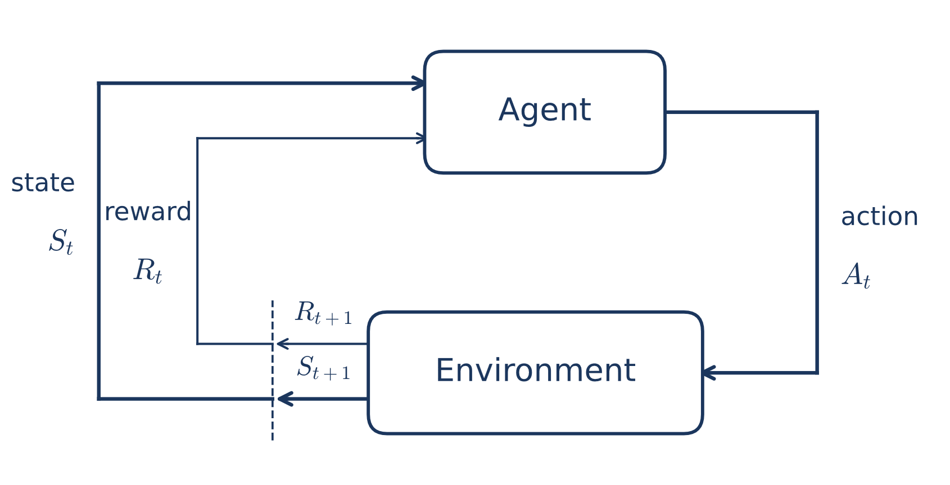
Figure 1 MDP process diagram.

The main objective of an agent is to maximize the discounted sum of rewards from time t to infinity, denoted by $R_{t}$ , which is expressed as follows
$$R_{t}= R_{\left\{t+1\right\}}+ γR_{\left\{t+2\right\}}+ γ^{2}R_{\left\{t+3\right\}}+ …= \sum_{k=0}^{∞}{γ^{k}r_{t+k+1}}$$
Equation 10 Reward function of MDP process.
Where $γ$ is a discount factor, specifying the future rewards. The agent's actions are guided by a policy $π$, which specifies what to do given the states of the environment. Each policy is associated with a state-value function $V^{π}(s)$, which predicts the outcome for state $s$ when following policy $π$:
$$V^{π}\left(s\right)=E\left[R_{t} ∣ S_{t}=s\right]$$
Equation 11 State-value function.
Where $E$ indicates the expected value. The optimal value of state $s$, $V^{*}(s)$ , is defined to map the maximum value over all possible policies:
$$V^{*}\left(s\right)=\max_{π} E\left[\sum_{t=0}^{∞}{γ^{t}R\left(s_{t},a_{t}\right)} ∣ s_{0}=s,a_{t}=π\left(s_{t}\right)\right]$$
Equation 12 Optimal state-value function.
The other related variable is an action-value function $Q^{π}(s,a)$, which gives the expected return when taking action $a$ in state $s$ and following policy $π$:
$$Q^{π}\left(s,a\right)=E\left[R_{t} ∣ s_{t}=s,a_{t}=a\right]$$
Equation 13 Action-value function.
The optimal Q-value of a state-action pair, $Q^{*}(s,a)$ is the maximum Q-value over all possible policies:
$$Q^{*}\left(s,a\right)=\underset{π}{max E}\left[\sum_{t=0}^{∞}{γ^{t}R\left(s_{t},a_{t}\right)} ∣ s_{0}=s,a_{0}=a,a_{t>0}=π\left(s_{t}\right)\right]$$
Equation 14 Optimal action value function.
In short, an optimal policy $π^{*}(s)$ is a policy whose state-value function is equal to the optimal value of the state. Modelling an accurate environment’s dynamics through MDPs is emphasized by many researchers in the field to obtain a robust framework and good results [49]. Adopting this process enables RL agents to adapt to complex and dynamic environments effectively, which is ideal for optimizing the operation of a polygeneration plant [50].

To select an appropriate RL strategy for optimizing an energy system, it is paramount to understand the different structural arrangement that differentiates modern RL algorithms. RL algorithms are primarily categorized along two fundamental axes: (1) Model-based vs. Model-free RL, which specifies how the agent-environment dynamics, and (2) Value-Based, Policy-Based, and Hybrid Actor-Critic architectures, which determines how control policies are learned and updated. Depending on the type of system, data availability, and objective, one arrangement can be favored over the others.

Environmental Dynamics of RL: Model-Based vs. Model-free
- Model-Based RL: The agent uses an explicit model of the system dynamics to plan future actions by simulating potential trajectories (e.g. Dyna-Q, Monte Carlo Tree Search, Model Predictive Path Integral control). In other words, the knowledge of the model directly influences the agent’s decision in choosing its next action. Although this approach introduces better sample efficiency, model-based RL often leads to longer online execution time and model-bias error which can be detrimental for highly complex and non-linear polygeneration system [].
- Model-Free RL: The agent treats the model of the system as a black box and purely relies on the navigating the accessible levers and system feedback to dictate its policy. As a consequence, this strategy requires significantly more data and longer training time for the agent to finally understand the underlying physics of the system. However, with a robust and accurately representing digital twin of the system, the agent can use the digital environment to generate as much data as it needs during the training period to finally reach a good policy while avoiding model-bias because all the physics are governed inside the digital twin black box [].

Policy Optimization Algorithms: Value-Based, Policy-Based, and Actor-Critic
There are different types of RL algorithms to be chosen for complex energy system optimization and control. The types of RL algorithms are usually divided into three parts: value-based RL, policy-based RL, and actor-critic, which sits in between them. The difference between these different types lies in the learning methodology for the RL agent. Value-based RL learns a value function, usually a Q(s,a) estimate, and then chooses an action that returns the best estimated value. Some examples of value based RL are Q-learning and Deep Q Network (DQN) [51]. A study argues that value-function methods can run into convergence trouble, especially when the system is in continuous, multivariate settings. This algorithm excels in controlling and optimizing discrete choices but not continuous ones [52].

On the other hand, Policy-based RL learns the Policy directly, which means it parametrizes the action rule itself and pinpoints the optimal policy with methods like policy gradients and PPO [53]. There is much literature on RL that simply applies a value-based approach, however, since energy problem are often continuous, high-dimensional, and constrained, policy-based approaches are usually preferred [54].

Actor-critic methods are a mix of the two: the actor learns the policy, while the critic learns the estimated value to make training more stable. In the literature, earlier studies still adopted Q-learning, but newer research starts to implement actor-critic and other deep RL variants for complex control tasks [55]. This actor-critic method includes Proximal Policy Optimization (PPO), Soft Actor-Critic (SAC), Asynchronous Advantage Actor-Critic (A3C), Twin Delayed Deep Deterministic Policy Gradient (TD3), and Deep Deterministic Policy Gradient (DDPG). Numerous studies have shown the application of this algorithm method into different kinds of energy systems and concluded that it performs best when uncertainty, continuous control, and multi-timescale coordination matter [47], [56].

RL vs MILP for Different Energy System Applications
In recent years, there have been multiple attempts in the literature to benchmark the results of RL and MILP for various energy system problems. Vetter et al. [26] analyzed the implementation of a deep reinforcement learning framework using the Deep Q-Network (DQN) algorithm to optimize the control of heat pump and heating element operation in a Grid-PV-Thermal Energy Storage (TES) system for an energy community. In this study, both frameworks are used to optimize only the dispatch strategy of the energy system in a fixed sizing environment. Furthermore, the RL agent’s action is only limited to controlling the SOC of the thermal energy storage, while observing its impact on the environment or state it can see. On the other hand, the MILP framework decides the flow of grid power and heating element at each time step. The result of this research shows that both frameworks successfully produce yearly cost savings compared to the reference scenario, with MILP having greater cost savings of a 10.06% reduction compared to 8.78% for RL. Aside from the cost result, the RL solution leads in terms of other metrics such as CO2 emission reduction, self-consumption ratio, and self-sufficiency ratio, without explicitly optimizing them. This is because RL decides to use more PV, which further reduces CO2 emissions.

Other than benchmarking the two frameworks for operational dispatch, some researchers also conducted a comparative analysis on RL and MILP for optimizing both the design and control decisions. Cauz et al. [57] used Battery-PV systems as their subject of analysis in order to test and optimize the performance of RL and MILP. The RL algorithm used here is the Direct Environment and Policy Search (DEPS). The design problem here lies in sizing the battery and PV power, whereas the control problem lies in dispatching battery and grid operations. The comparison is done in two stages: the first stage only involves one week of operation, and the second stage tests both frameworks’ performance in a one-year case study. For the first stage, the authors discovered that under a fixed sizing scenario, both frameworks manage to converge to the global optimum. However, while introducing the design decision problem, the RL at first managed to produce a better result in terms of cost; however, the authors later found that this is due to the modelling limitations that the RL excludes, which is the battery SOC balance at the end that should be the same as the initial SOC state. With this assumption being included in the calculation, the cost result of RL drops, and MILP prevails to become cheaper. This shows how important the modelling phase and identical assumptions are for a fair comparison. Interestingly, the RL approach manages to converge to a near-optimal solution with a design variable that is significantly different from the MILP: 62 kWh and 41 kWp for RL and 40 kWh and 103 kWp for MILP for battery and PV, respectively, with the RL layout having 145.65% of the cost of MILP after considering the additional SOC calculations.

In the second stage of this study, the RL approach failed to converge to the same cost value of MILP under the fixed sizing scenario, with it being 12% more expensive. Under the joint operational and sizing decision optimization scenario, RL ends up having 22% more cost than MILP, while the design decisions are significantly smaller than MILP (44 kWh & 57 kWp for RL and 95 kWh & 81 kWp for MILP for battery and PV, respectively). According to the authors of the study, this poorer performance of RL could be due to a lot of reasons; two of the notable reasons include hyperparameter tuning and the outdated RL algorithm chosen, which was developed in 1992.

Reviews now identify TD3, SAC, Multi-Agent Reinforcement Learning (MARL), and PPO as the main advanced RL families being adopted for energy management, especially in online or uncertainty-heavy settings [58]. As an on-policy policy-gradient framework, PPO utilizes a clipped surrogate objective function that constrains policy updates within a selected trust region, which ensures high training stability and steady convergence across continuous control domains [59]. In one study on optimizing the operation of multireservoir hydropower, Castro-Freibott et al. [60] implemented different RL algorithms (A2C, PPO, and SAC) in comparison to an MILP baseline. The experiment demonstrated that MILP achieves superior performance in the smaller system, but
PPO was the strongest RL method tested and scaled far better than MILP when the system gets bigger. This result also shows that PPO could maintain consistent performance across discrete and continuous action spaces while achieving it with less than one second of execution time.

Another study compared four RL algorithms: PPO, A2C, SAC, TD3 for a battery power plant control problem and demonstrated TD3 superior results among the RL algorithms and outperformed MILP by 5% in cost savings [61]. On the other hand, a comparative analysis on optimizing renewables penetration in modern smart grids was conducted between rule-based, MILP, and DRL algorithms (DDPG, PPO, SAC). The result demonstrated SAC superiority in delivering the best results, reducing operational costs by 20%, achieving 92.8 % renewable application, while minimizing loss-of-load probability [62]. From diving deep into the literature, it is possible to argue that many RL strategies are already competitive with MILP, or even some better; however, this is highly dependent on the system complexity and uncertainty assumption.

Methodology

Hybrid Biomass Power-to-Methanol System Model

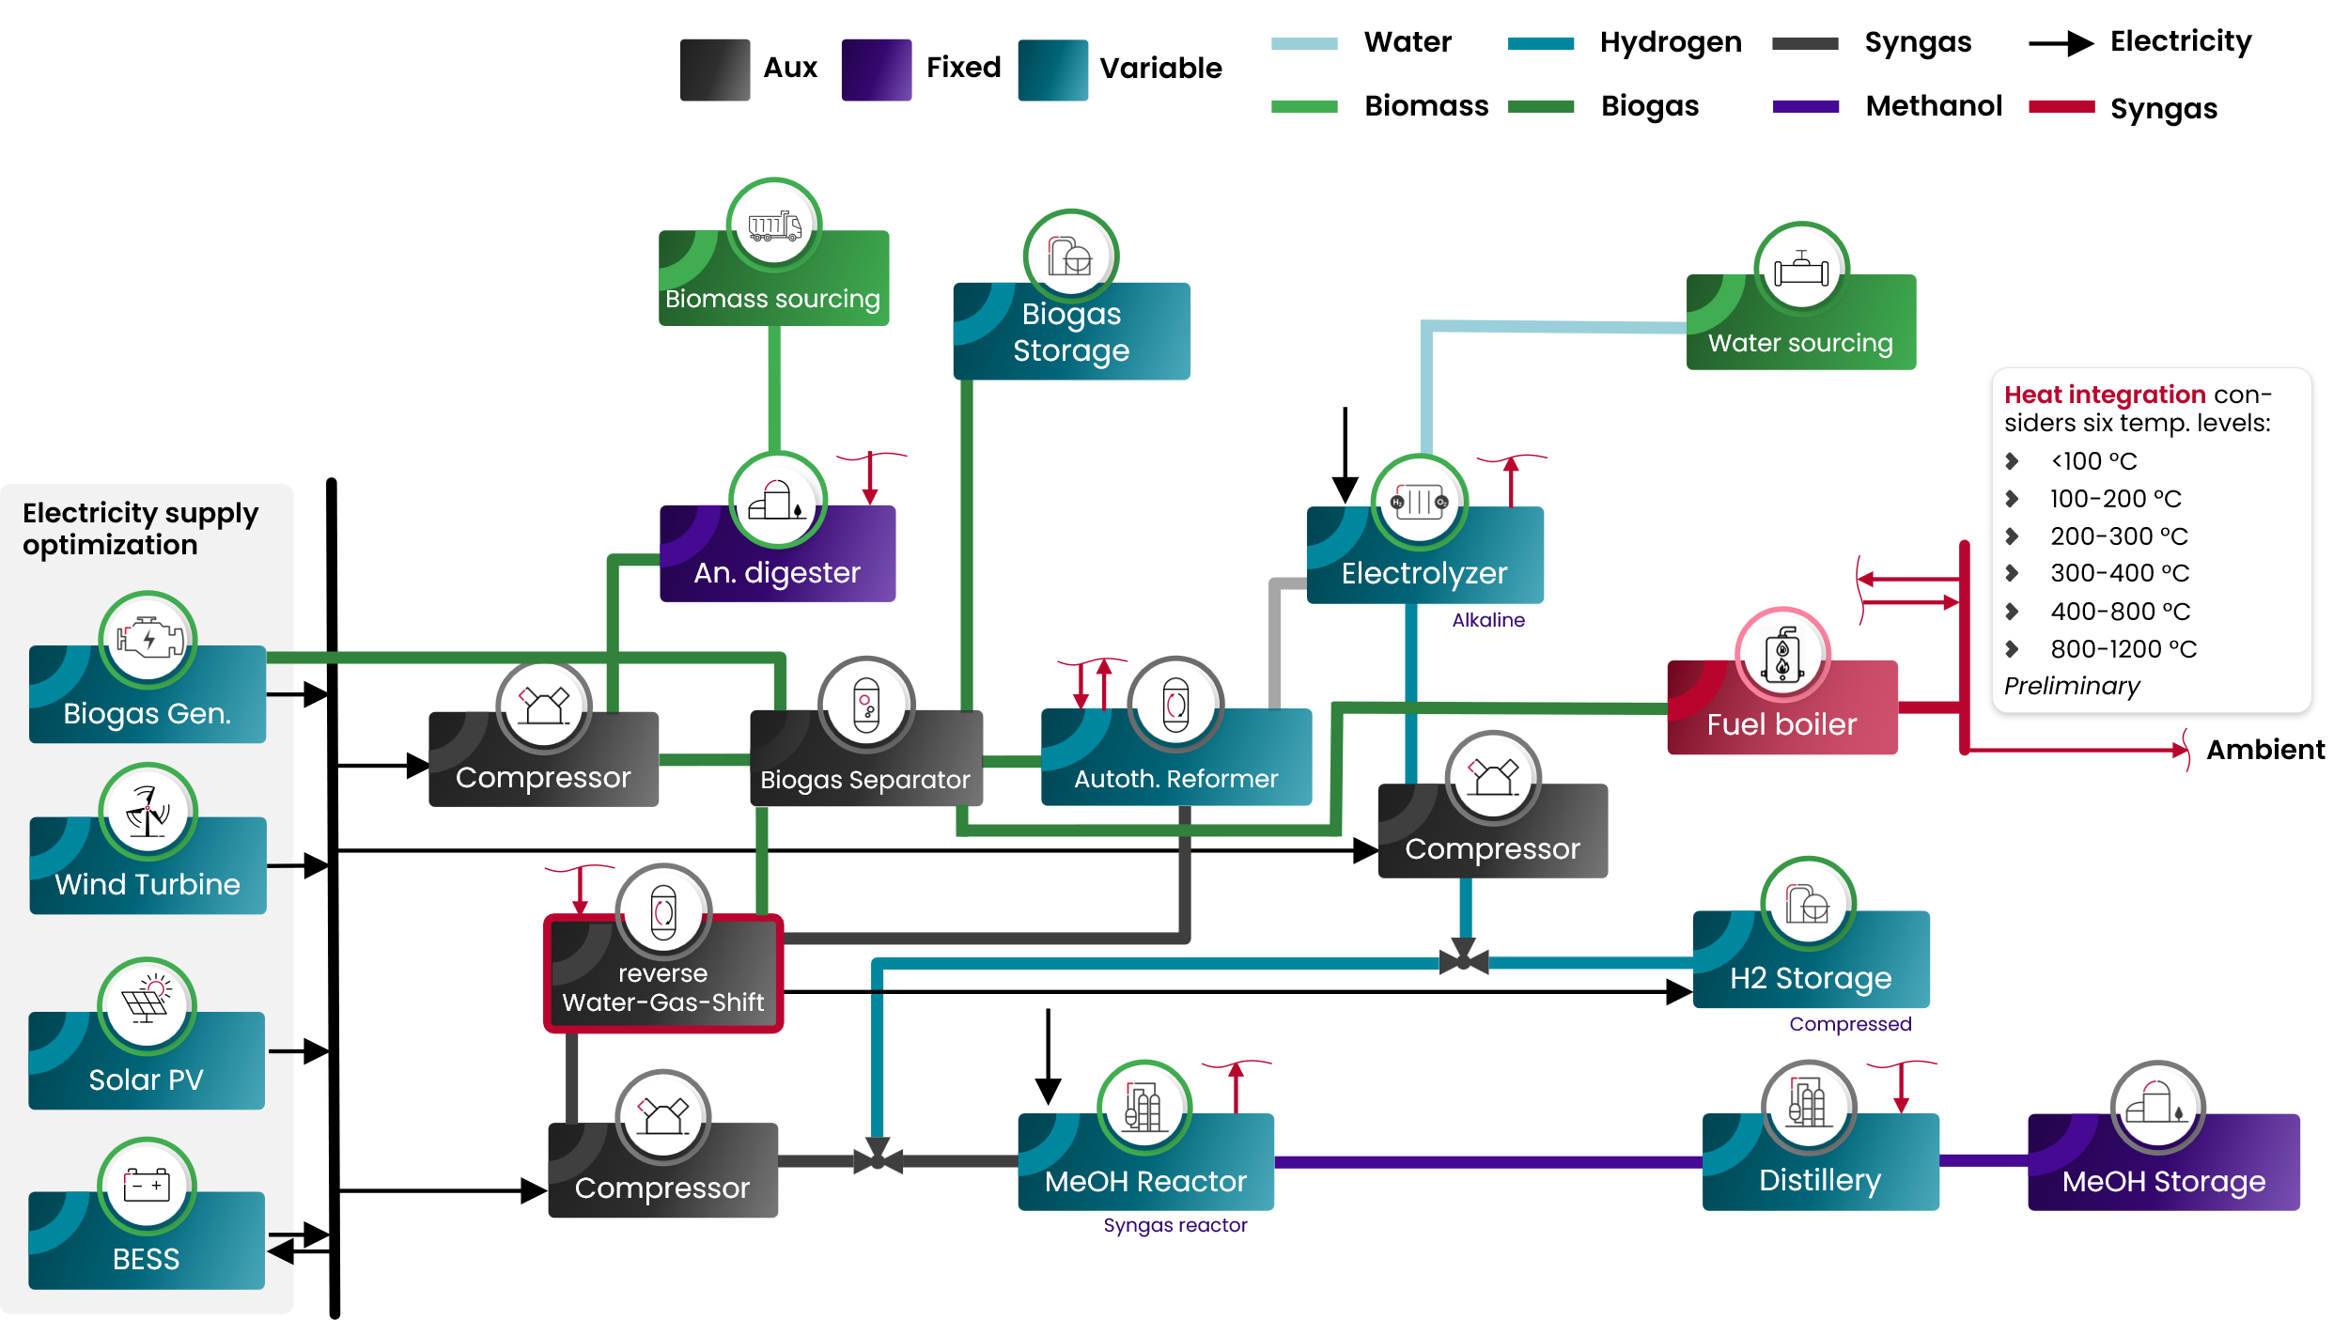
Figure 2 BOP of the Hybrid Biomass Power-to-Methanol System (BPtMeOH).

The model developed for this comparative analysis represents a hybrid biomass power-to-methanol (BPtMeOH) architecture. The complete high-level balance of plant (BOP) for this integrated system is illustrated in the preceding figure. Within this configuration, methanol production is driven by two parallel upstream conversion pathways: the generation of a carbon-rich stream via biomass anaerobic digestion, and the production of hydrogen utilizing an alkaline water electrolyzer (AWE).

Before reaching the methanol synthesis loop, the biogenic gas undergoes a sequence of intermediate conversion processes. Initially, raw biogas is fractionated into methane and carbon dioxide; the methane is routed to an autothermal reformer (ATR), while the carbon dioxide is directed to a reverse water-gas shift (RWGS) reactor. Within the ATR, the methane undergoes partial oxidation using byproduct oxygen supplied by the AWE. This triggers an autothermal reforming process, generating a primary syngas rich in carbon monoxide (CO) and hydrogen.

This intermediate syngas is subsequently fed into the RWGS unit, where it mixes with the previously separated carbon dioxide. The RWGS reactor serves a critical regulatory function, converting carbon dioxide into additional CO to dynamically balance the hydrogen-to-CO ratio required for optimal methanol synthesis, thereby introducing operational flexibility depending on real-time limiting factors. In parallel, the AWE generates ultra-pure hydrogen, which is subjected to a multi-stage compression process before converging with the conditioned syngas immediately upstream of the methanol synthesis reactor. The combined upstream gases are then catalytically converted into crude methanol, which undergoes distillation to achieve the required purity prior to transport and storage.

For both the biogenic and hydrogen paths, an intermediary storage of Biogas Storage (BGSS) and Compressed Hydrogen Gas Storage (CGH2) are introduced. These storage components allow the system to react to the variable renewable energies

The system's electrical demand is satisfied by on-site renewable energy installations, comprising solar photovoltaic (PV) and wind turbine capacities. To ensure operational reliability and mitigate the intermittency of these renewable sources, a backup biogas generator is integrated into the architecture; this generator is fueled by methane routed directly from the upstream biogas separation unit.

For the biogenic, hydrogen, and electricity paths, an intermediary storage of Biogas Storage (BGSS), Compressed Hydrogen Gas Storage (CGH2), Battery Energy Storage System (BESS) have been introduced. These storage components allow the system to react to the variable renewable energies to find the optimal dispatch in maximizing methanol production. However, this is subject to the solver decision as the solver has the ability to decide the economic competitiveness of these components in reducing total cost or LCOM.

Conversely, the primary thermal energy requirements are provided by a high-temperature fuel boiler operating within the 800–1200 °C range. To maximize overall thermodynamic efficiency, the thermal management system employs a cascaded heat integration strategy. As dictated by the system architecture, this heat recovery network is discretized into six distinct temperature levels ranging from below 100 °C up to 1200 °C, to systematically capture and recycle waste heat from the various exothermic conversion processes occurring throughout the plant.

To formulate a rigorous computational optimization problem, the system components are mathematically classified into three fundamental categories based on their sizing logic and operational constraints:

- Fixed Variables: These parameters define the pre-determined infrastructural baseline required for the plant's operation. By enforcing mandatory capital investments for these core components, a hard constraint is imposed on the solver. This crucially prevents the optimization algorithm from trivially converging on a zero-capacity, zero-cost null state.
- Decision Variables: These represent the primary control parameters that the optimization methodology actively solves. The algorithm iteratively determines the optimal installed capacities for these components to minimize overall system costs, operating strictly within the boundaries established by the fixed variables.
- Auxiliary Variables: The sizing of these dependent, balance-of-plant components is not determined independently by the solver. Instead, their capacities are deterministically scaled as a direct mathematical function of the corresponding fixed and decision variables.

The subsequent table summarizes the scaling logic for the system architecture, detailing how each component's capacity is dimensioned relative to its designated lead variables.

Table 4 Components of BPtMeOH and their parameters.
Components | Types | Lead Variables | Dependency
AD | Fixed | Biogas | -
MeOH Storage | Fixed | Methanol | -
WT | Variable | Electricity | -
PV | Variable | Electricity | -
BESS | Variable | Electricity | -
AWE | Variable | Electricity | -
ATR | Variable | Syngas | -
CGH2 | Variable | Hydrogen | -
BGSS | Variable | Biogas | -
Generator | Variable | Electricity | -
MeOH reactor | Variable | Methanol | -
Distillery | AUX | Methanol | MeOH Reactor
Biogas Compressor | AUX | Electricity | AD
Steam Generator | AUX | Heat 300-400°C | ATR
RWGS | AUX | CO2 | AD
Compressor Syngas Medium to High Pressure | AUX | Electricity | MeOH Reactor
Compressor H2 Low to Medium Pressure | AUX | Electricity | AWE
Compressor CGH2 | AUX | Electricity | AWE
Fuel Boiler | AUX | Heat 800-1000°C | ATR

The selected fixed Capital Expenditure (CAPEX) and Operational Expenditure (OPEX) parameters of the components in the table above have been retrieved from the internal economics database from FEV Europe GmbH. Additionally, the meteorological inputs required to model renewable energy generation, specifically solar irradiance and wind speed, are derived from coordinate-specific data for Johannesburg, South Africa, obtainthevia the open-source platform Open-Meteo. Given the location's placement in the Southern Hemisphere, the temporal definitions of the seasons are naturally inverted relative to standard Northern Hemisphere conventions. Accordingly, the temporal modeling parameters within this study define the summer period as spanning from November to March, while the winter season is defined from June to August.

MILP Optimization Framework Architecture
The computational framework developed for this study builds upon an existing modeling architecture at FEV Europe GmbH, utilizing the open-source energy system modeling library oemof.solph. This library functions as a high-level abstraction layer operating over the Pyomo optimization environment. Within this framework, all system components are mathematically formulated using strict linear representations. The model incorporates foundational linear constraints, including nodal mass and energy flow balances, component-specific operational boundaries (e.g., converter efficiency relations, generic storage state-of-charge dynamics, and power-to-heat ratios for combined heat and power units), and capacity investment optimization limits. Furthermore, optional case-specific constraints are explicitly embedded into the formulation. To maintain computational tractability and prevent the exponential scaling of simulation times typically associated with complex energy networks, the introduction of binary variables was deliberately omitted. Consequently, the optimization of the hybrid system is defined exclusively as a continuous linear programming (LP) problem.

To systematically construct the energy topology, the operational units within the linear model are classified into five fundamental categorical objects:
- Sources: Foundational generation nodes that explicitly introduce energy or mass flows into the system boundary.
- Converters: Transformation nodes that convert a predefined set of input streams into corresponding output streams, governed by strict, fixed linear conversion efficiencies.
- Buses: Centralized connective hubs that route flows between the various topological components, ensuring nodal balance throughout the network.
- Sinks: Terminal nodes that exclusively receive input flows, representing system demands, required loads, or boundary out-streams.
- Storages: Temporal buffering components capable of absorbing and retaining incoming mass or energy flows across multiple timesteps, sequentially releasing them back into the system to satisfy dynamic operational requirements.

Table 5 Linear component parameters
Components | Input | Output |  | Type
AD | Biomass, heat 60°C |  | Biogas, wastewater, digestate | Converter
MeOH Storage | Methanol |  | - | Sink
WT | - |  | Electricity | Sources
PV | - |  | Electricity | Sources
BESS | Electricity |  | Electricity | Storage
AWE | Electricity, water |  | Hydrogen, O2, heat 60°C | Converter
ATR | Methane, Heat 1000°C, O2, steam |  | Hydrogen, CO, wastewater | Converter
CGH2 | Ultra-high pressure hydrogen |  | High pressure hydrogen | Storage
BGSS | Medium pressure methane |  | Medium pressure methane | Storage
Generator | Medium pressure methane |  | Electricity, CO2 | Converter
MeOH reactor | Hydrogen, CO, CO2, Electricity |  | Methanol | Converter
Distillery | Methanol |  | Methanol | Converter
Biogas Compressor | Low pressure biogas |  | Medium pressure biogas | Converter
Biogas Separator (CO2 Removal) | Biogas |  | Methane, CO2 | Converter
Steam Generator | Water, heat 300-400°C |  | Steam | Converter
RWGS | Hydrogen, CO2, heat 200-300°C |  | CO, Steam | Converter
Compressor Syngas Medium to High Pressure | Electricity, medium pressure syngas |  | High pressure syngas | Converter
Compressor H2 Low to Medium Pressure | Electricity, low pressure hydrogen |  | Medium pressure hydrogen | Converter
Compressor H2 Medium to High Pressure | Electricity, medium pressure hydrogen |  | High pressure hydrogen | Converter
Compressor CGH2 | Electricity, medium pressure hydrogen |  | Ultra-high pressure hydrogen | AWE
Fuel Boiler | Medium pressure methane |  | Heat 800-1000°C | Converter
Heat exchangers (4 stages) | Heat high |  | Heat lower | Converter

The proposed Mixed-Integer Linear Programming (MILP) optimization framework is designed to operate in two distinct modes: the co-optimization of system sizing and operational dispatch, and the optimization of dispatch under fixed capacity constraints. The co-optimization pathway concurrently evaluates optimal component capacities (sizing variables) alongside their corresponding operational schedules (dispatch variables). By formulating the system as a comprehensive linear programming problem, this approach balances the maximization of revenue with the minimization of both capital expenditures (CAPEX) and operational expenditures (OPEX). Conversely, the dispatch-only configuration utilizes predefined component sizes. Its primary function is to compute the optimal operational strategy that maximizes revenue and minimizes OPEX under fixed capacity constraints.

Upon defining the model architecture and selecting the operational mode, the formulation is processed using the COIN-OR Branch and Cut (CBC) MILP solver. This solver evaluates the overarching objective function subject to the established linear constraints to systematically identify the global optimal solution.

Mathematically, the primary objective function is formulated to minimize the net system cost. This is calculated as the sum of the annualized CAPEX and OPEX, minus the projected revenue (defined as the product of the total volume of methanol produced and the assumed market price of methanol). Furthermore, a supplementary performance metric—the unit cost of methanol production—is derived by dividing the sum of the annualized CAPEX, OPEX, and variable cost ($C_{var}$: Biomass Feedstock, Water import, CO2 emission cost) by the total volume of methanol produced.
$$\min{Z}={\text{CAPEX}}_{\text{annualized}}+{\text{OPEX}}_{\text{annual}}-\left(M_{\text{MeOH, annual}}⋅C_{\text{MeOH, assumed}}\right)$$
Equation 15
$$\text{LCOM}=\frac{{\text{CAPEX}}_{\text{annualized}}+{\text{OPEX}}_{\text{annual}}+C_{var}}{M_{\text{MeOH, annual}}}$$
Equation 16

Reinforcement Learning Optimization Architecture
The RL optimization framework has also been established in-house at FEV Europe GmbH based on open source tools such as stable-baseline3, OpenAI gymnasium, pytorch as an alternative optimization solution introducing higher fidelity of per-component non-linear modelling and also the novelty of reinforcement learning agent to optimize the operational dispatch of the system. The RL framework allows the adoption of both linear and non-linear model since the model is essentially a black box to the agent itself, thus, offering higher degree of freedom.

Input, output, and conversion factors definition in the linear model is fully utilized in order to have a 1-to-1 comparison with the MILP framework. By aligning all the techno-economic parameters, translating a global linear constraint of MILP into a step function-based RL framework, a fair comparison of these two methodologies can be made possible. Only then, it is also interesting to observe high-fidelity operation under different control strategies.

To evaluate the dispatch agents under realistic physical constraints, high-fidelity non-linear representations of the Alkaline Water Electrolyzer (AWE) and Compressed Gas Hydrogen storage (CGH2) were integrated into the simulation framework. In this study, they serve as non-linear simulation environments to benchmark dispatch adaptability. To avoid comparing two fundamentally different components between the linear and non-linear configuration, an alignment of the parameterization between the linear and non-linear models has been performed such that the baseline (mean) efficiency of the non-linear component is equivalent to the flat linear efficiency for both AWE and CGH2. The specific non-linear phenomena captured by these components and how they contrast with the linear oemof.solph formulation are summarized below.
- AWE: The alkaline water electrolyzer is modelled as a series stack of $N_{\text{cells}}$ identical cells operating in a concentrated potassium hydroxide (KOH) electrolyte at a fixed temperature and pressure. Rather than assuming a fixed efficiency, the model resolves the full electrochemical transfer function at each timestep: it converts the commanded electrical power into a stack current and cell voltage, and from that current derives the faradaic gas production, the crossover and dissolution losses across the separator, and the resulting product purity. Because the stack current and cell voltage are mutually dependent (voltage rises with current, which in turn changes the shunt losses), the solution is obtained by an internal fixed-point iteration. The high level equations are presented below:
$$U_{\text{cell}}=\frac{U_{\text{ohm}}(I)+U_{\text{Nernst}}+U_{\text{act,a}}(I)+U_{\text{act,cat}}(I)}{n_{\text{cells}}}, I_{s}=\frac{P_{\text{stack}}^{\text{DC}}}{N_{\text{cells}} U_{\text{cell}}}$$
Equation 17 Power-derived cell voltage and current equation.
$${\dot{n}}_{{\text{H}}_{2}}=\frac{I_{\text{el}}}{2F} N_{\text{cells}}$$
Equation 18 Hydrogen stream output.
- CGH2: The hydrogen storage system is modelled as a fixed-volume, isothermal pressure vessel with an isentropic compressor on the charge path and an optional isentropic expander on the discharge path. The state is the stored hydrogen mass, which maps directly to tank pressure through the ideal-gas law. Each timestep the model saturates the commanded mass flow against the charge/discharge rate limits and the usable pressure window, updates the stored mass, and computes the compression power. The essential difference is that the storage penalty becomes a pressure-dependent, physically-grounded electricity demand rather than a flat efficiency: the compressor work grows as the tank fills, and the usable capacity is bounded by real minimum/full pressures instead of an abstract SoC band.
$$p_{\text{tank}}=\frac{mRT}{V}$$
Equation 19 State of the tank is the pressure derived using the ideal gas law.
$$P={\dot{m}}_{\text{act}} \frac{c_{p}T}{η_{\text{iso}}}\left[{\left(\frac{p_{\text{tank}}}{p_{\text{in}}}\right)}^{\frac{γ-1}{γ}}-1\right]$$
Equation 20 Isentropic compression (or expansion) equation.

Both the linear and non-linear model is built with the basis of a step function for each of the component’s module. This step function is regulated by the evaluation order that dictates which component’s step function is conducted first until last which is highly contrast compared to the MILP framework that encapsulates everything to one large equation. The evaluation order is highly integral in the behavior and the performance of the energy system model. Take the RWGS and ATR as an example, if the step function for the RWGS occurs first before ATR, the medium pressure syngas will be empty when the RWGS request for the species, which in the end will result in infeasibility due to the deficit of the stream. Therefore, it is paramount to organize the evaluation order in a way that reflects the real operation of the plant. For this hybrid system, the evaluation order is summarized in the table below.

Table 6 Evaluation order for RL environment.
Components | Evaluation order
PV | 1
WT | 2
AWE | 3
AD | 4
Biogas Compressor | 5
CO2 Removal | 6
ATR | 7
Compressor H2 Low to Medium Pressure | 8
Compressor H2 Medium to High Pressure | 9
RWGS | 10
Compressor Syngas Medium to High Pressure | 11
MeOH reactor | 12
Compressor CGH2 | 13
CGH2 | 14
Distillery | 15
MeOH Storage | 16
Steam Generator | 17
Heat Exchangers (4 stages) | 18
Fuel Boiler | 19
Generator | 20
BESS | 21
BGSS | 22

There are three available controllers in this framework: Conventional generalized rule-based controller (RBC), ideal control (IC), and RL. The RBC is a general rule that forces a component to simply process every stream passing through it and transferring the responsibility to satisfy remaining imbalances to a connected storage either to store or satisfy this imbalances. The IC controller is implemented as a validation step controller on running an equivalent linear model of the MILP framework in the RL framework before passing it to the RL controller. This controller simply takes the key components timeseries profile from the MILP framework, normalize them, and use them as an imposed controller for these key components, while the other components use the RBC controller. If the result of this IC controller is equal to the MILP counterpart, only then it is clear that the linear model is 1-to-1 equivalent and ready to be run with the RL controller.

RL agent parameters
SAC algorithm has been selected for the RL controller due to its superiority in handling continuous dispatch with efficient use of data, and clear exploitation and exploration definition as learned in chapter 2. The figure below visualizes how the logic diagram of how the actor and critic agent optimizes the hybrid system.
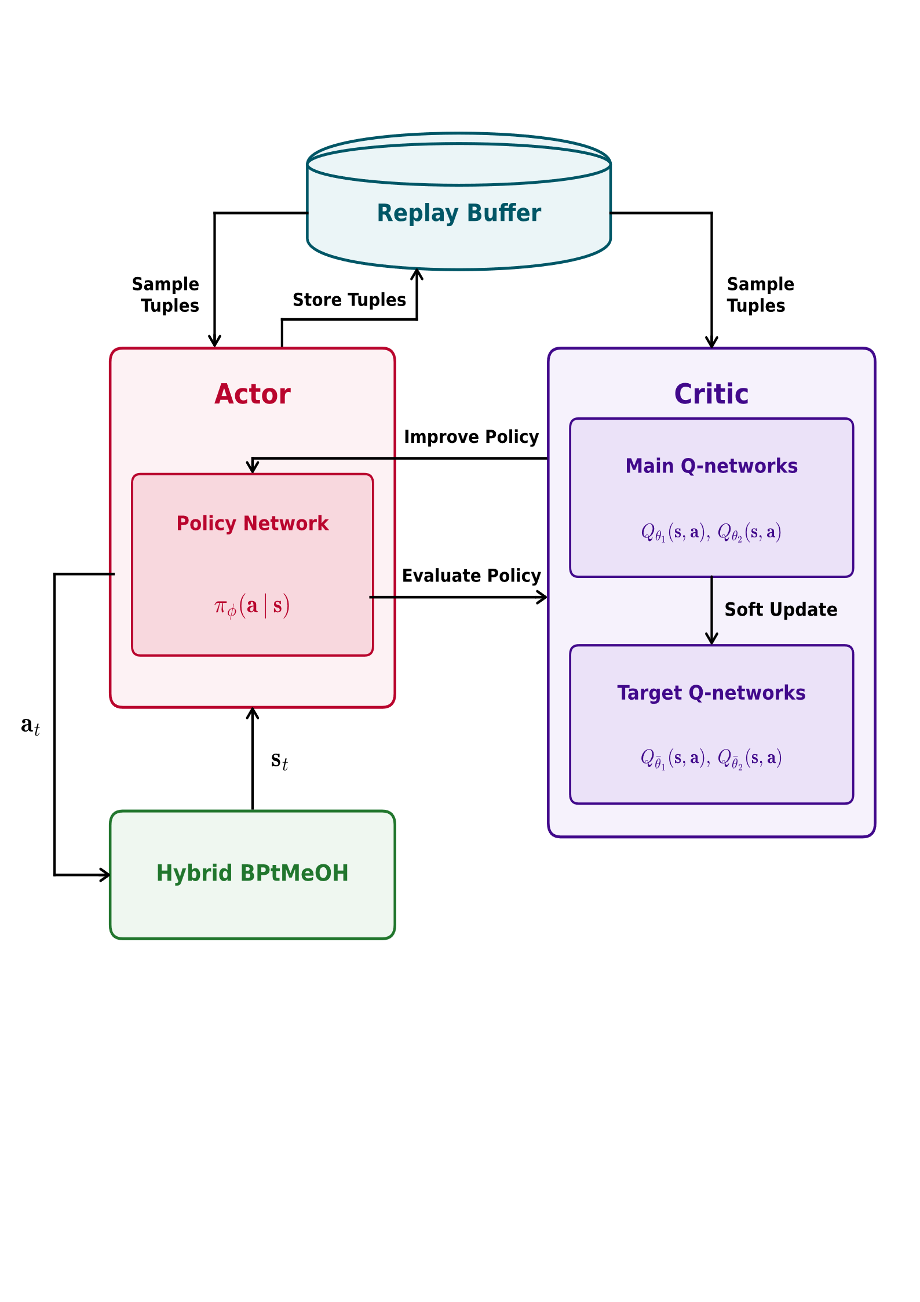
Figure 3 RL SAC algorithm process diagram [63].
The agent controls the plant through a fixed action/observation contract. At each control step it reads a normalized observation vector describing the plant state and near-term forecast and emits a set of continuous commands that are applied to the dispatchable components. All actions are continuous relative-load commands in the range [0, 1]; each value is a fraction of the target component's own rated capacity, which the component then scales internally. This keeps the action space dimensionless and capacity-independent, so the same policy transfers across differently sized layouts. The agent owns the following five control channels:
Table 7 Components assigned as control channels for RL agent.
Component | Control Target
Digester | Biomass feed load (fraction of design feed rate)
ATR | Biogas throughput to the autothermal reformer
AWE | Electrolyser power load (with a minimum-load floor Prel_min)
RWGS | CO₂ conversion load in the reverse water-gas-shift unit
Generator | AC generator dispatch load

Only these components are RL-controlled; all remaining components are handled by RBC.

Along with the action-owned components, the RL agent is also given some states to observe throughout its training process. Observations are drawn from live component state, a time feature, and a rolling forecast, and every channel is normalised to a common scale (clipped to [0, 1]) so the network sees comparable magnitudes.
Table 8 Observation slots of the RL framework.
Observation slot | Description
BESS SOC | Battery storage state of charge
CGH2 SOC | Hydrogen storage state of charge
BGSS SOC | Biogas storage state of charge
PV profile | PV output, normalised by installed PV capacity
WT profile | Wind output, normalised by installed wind capacity
Methanol reactor hydrogen demand | Make-up H₂ demand of methanol synthesis
noonness | Hour-of-day encoded as -cos(2π·h/24) (peaks at solar noon)
Weather Forecast | 7-day rolling forecast of DNI, DHI and 100 m wind speed, aggregated into 7×4 binned means

Together the state-of-charge, renewable-output, and demand channels give the agent the current energy balance; noonness and the 7-day forecast give it the temporal context needed to plan storage and production ahead of expected renewable availability.

The agent optimizes the hybrid system with the basis of an incentive defined in the reward function. Since the RL agent is fed with a fixed system layout, which also means the same CAPEX & OPEX, the reward function simply incentivizes the agent to produce as much Methanol as possible with the given system configuration. The reward function has developed from being a linear cap that triggers penalties to some boundary conditions to a gradient that guides the agent to learn more about the system, specifically for generator ramping operation and storage SOC boundaries.
$$r_{t}=r_{\text{MeOH}}-P_{\text{BESS}}-P_{\text{BGSS}}-P_{\text{H2SS}}-P_{\text{fuel}}-P_{\text{cyc}}-P_{\text{CO2}}-P_{\text{term}}$$
Equation 21 Reward function where r is reward and P is penalty.
The single positive term rewards the mass of methanol synthesized during the timestep:
$$r_{\text{MeOH}}=w_{\text{MeOH}} {\dot{n}}_{\text{MeOH}} Δt M_{\text{MeOH}}$$
Equation 22 Methanol reward definition.
where ${\dot{n}}_{\text{MeOH}}$ is the summed molar production rate across all synthesis units, $Δt$ is the timestep lengths, and $M_{\text{MeOH}}=0.032042 \text{kg/mol}$. The gradient for SOC penalties are represented below:
$$P=w\sum_{i}{\left\{\begin{matrix}{\left(\frac{{SoC}_{\text{low}}-{SoC}_{i}}{{SoC}_{\text{low}}}\right)}^{2} & {SoC}_{i}<{SoC}_{\text{low}} \\ {\left(\frac{{SoC}_{i}-{SoC}_{\text{high}}}{1-{SoC}_{\text{high}}}\right)}^{2} & {SoC}_{i}>{SoC}_{\text{high}} \\ 0 & \text{otherwise}\end{matrix}\right.}$$
Equation 23 Quadratic penalty for SOC boundary.
The excursion is normalized by the distance to the physical limit (0 or 1) so the penalty grows smoothly from 0 at the band edge to 1 at total failure, then squared to punish deep breaches disproportionately. For the generator cycling penalty gradient, the equation below is implemented:
$$P_{\text{cyc}}=w_{\text{cyc}}\sum_{i}{{\left(\frac{\left|P_{i}^{\left(t\right)}-P_{i}^{\left(t-1\right)}\right|}{P_{\text{rated}}}\right)}^{2}}$$
Equation 24 Quadratic penalty for generator ramping.

Table 9 Penalty summary.
Penalty & Rewards | Trigger boundary | Gradient shape | Weight
State-of-charge (BESS / BGSS / H2SS) | $SoC<{SoC}_{\text{low}}$ or $SoC>{SoC}_{\text{high}}$ (defaults 0.05 / 0.95) | Normalised quadratic | $$w_{\text{BESS}}, w_{\text{BGSS}}, w_{\text{H2SS}}$$
Generator fuel | Any fuel consumed | Linear in fuel mass [kg] | $$w_{\text{fuel}}$$
Generator cycling | Any change in AC power between steps | Normalised quadratic | $$w_{\text{cyc}}$$
RWGS CO2 | RWGS CO2 emitted | Linear in CO2 mass [kg] | $$w_{\text{CO2}}$$
Terminal breach | Unmet bus balance | Flat per occurrence then stops the episode early | $$w_{term}$$
MeOH (reward) | MeOH produced | Linear in MeOH mass [kg] | $$w_{MeOH}$$

These actions, observations, and rewards input are then fed to an agent with a specific hyperparameter setting which governs the learning behavior of the agent that are not learned from data. They control how the agent explores, how quickly it updates its policy, and how it weighs immediate against future reward. Because each environment step is a physical-plant simulation, training is expensive, so these values must be chosen to keep learning stable and sample-efficient while still exploring enough to discover good long-horizon dispatch strategies. Since hyperparameter tuning to optimize the agent performance is not the main focus of this thesis, the author has only attempted a minimal iteration to promote the RL balancing exploration and exploitation to achieve a good performance. Table 10 below summarizes the hyperparameter settings of the RL agent.
Table 10 Hyperparameter setting of the RL agent.
Hyperparameter | Value | Role
policy | MlpPolicy | Policy/value network architecture (multilayer perceptron)
buffer_size | 300,000 | Replay buffer capacity (stored past transitions)
learning_starts | 672 | Random-action warm-up steps before training begins
train_freq | 20 | Environment steps between training updates
gradient_steps | 20 | Gradient updates per training trigger
batch_size | 256 | Transitions sampled per gradient update
learning_rate | 3×10⁻⁴ | Optimiser step size for actor/critic networks
tau | 0.005 | Soft target-network update coefficient (Polyak averaging)
gamma | 0.999 | Discount factor for future rewards
ent_coef | auto_0.5 | Entropy temperature (exploration), auto-tuned from 0.5
target_entropy | auto | Target entropy driving automatic ent_coef adjustment

With the actions, observations, rewards, and hyperparameters in place, the RL agent can now start with the training and validation step. Training is carried out with Stable-Baselines3, which interacts with the plant through a Gymnasium environment wrapper. At each step the environment scales the agent's actions into component commands, advances the physical-plant simulation by one control interval, computes a reward, and returns the next observation, so that learning is driven directly by the plant dynamics rather than a surrogate model.

The unit of interaction is the episode, defined here as one continuous four-week operating window of 28 days, which corresponds to 672 steps at a 60-minute cadence in the hourly profile. Whenever an episode begins, the environment resets the plant state and loads a fresh 28-day weather slice together with the matching rolling forecast windows. Episode start days are sampled from the assigned data split, drawn at random during training to expose the agent to varied conditions, and fixed as the entire one year period during evaluation so that results are directly comparable. Training then proceeds for a configured number of episodes, giving a total environment interaction of episodes × steps-per-episode, and it begins with a short warm-up phase in which the replay buffer is filled with exploratory transitions before any gradient updates are applied.

To keep training and testing honest, the available weather windows are partitioned into a train and validation split, with a buffer between bands so that no episode overlaps two splits, and a full period weather is locked away and never seen during training to provide an unbiased final evaluation. Evaluation itself is always run with a deterministic policy with no exploration noise. During training the current policy is periodically evaluated on the full one-year period, and these validation scores drive checkpoint selection and early stopping. The final assessment then runs the best found policy on the held-out data as a full operational year and reports per-run metrics such as methanol yield, cumulative reward, and any early-shutdown events, to be benchmarked against LP counterpart. With this training and evaluation process, the RL becomes weather-agnostic, ready to be deployed under any weather scenario.

Bi-level Sizing and Dispatch Optimization Strategy
To further explore the significance of linear versus non-linear modeling in optimizing a complex hybrid energy system, a bi-level Bayesian Optimization (BO) strategy has been integrated with the existing framework. Adopting this architecture is a fundamental step in the methodology analysis for two primary reasons:

- Economies of Scale (Non-linear CAPEX): The inner-loop dispatch model has been intentionally formulated as a pure Linear Programming (LP) system to preserve computational efficiency, deliberately avoiding binary variables and piecewise linearization. Consequently, this strictly linear environment cannot natively model non-linear "economies of scale" for component capital expenditures (CAPEX). The bi-level strategy resolves this by preserving the rapid LP formulation for operational dispatch while wrapping a BO algorithm around it as an outer loop. In practice, the BO explores different equipment capacities and passes these as fixed boundaries to the inner LP loop. This iterative process allows the framework to accurately evaluate non-linear investment costs alongside operational dispatch, continuing until the BO locates the optimal combination of sizing capacities.
$$c=c_{ref}⋅{\left(\frac{S}{Sref}\right)}^{k}$$
Equation 25
- Non-linear Objective Function (LCOM): Beyond equipment scaling, a standard LP framework is mathematically restricted to linear objective functions, such as minimizing total absolute cost. However, the true optimal configuration for a hybrid methanol (MeOH) plant is dictated by the LCOM, rather than strictly the lowest overall expenditure. Because LCOM is a non-linear ratio, it cannot be optimized directly within the LP environment. The bi-level approach effectively shifts this non-linear evaluation outside the LP realm. For each iteration, the BO outer loop retrieves the total operating cost and the total MeOH produced from the inner loop. It then calculates the LCOM and uses this non-linear metric as its primary objective, guiding its probabilistic search—balancing exploration and exploitation—to pinpoint the global minimum.

As introduced in Chapter 2, Bayesian Optimization (BO) is a probabilistic, model-based optimization technique that efficiently navigates complex search spaces by balancing the exploration of highly uncertain regions with the exploitation of known, high-performing areas. In this bi-level framework, the objective variable is defined as the LCOM. The BO serves as an iterative outer loop, systematically proposing different combinations of component sizes and learning which configurations minimize the LCOM. The LP framework inner loop has been configured in a way that prevents any infeasibility of the system (e.g. balance, etc), thus, the BO sampler could learn the layout combinations smoothly without having pikes of artificial penalty in its surrogate model. The figure below illustrates this iterative mapping process, demonstrating how BO systematically narrows down the optimal design space by strategically balancing exploration and exploitation.
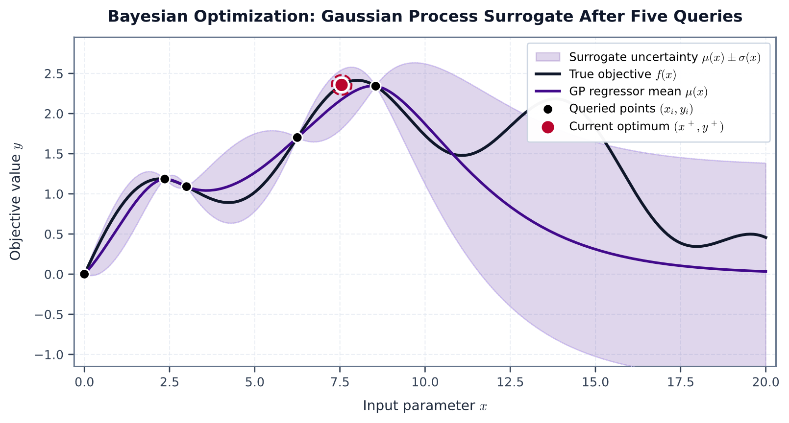
Figure 4 Gaussian process of bayesian optimization [64].

This figure illustrates the fundamental concept of Bayesian Optimization (BO) using a Gaussian Process (GP) after five queries or trials. The black line represents the true objective function that we are trying to map, and the purple line is the GP regressor mean, representing the surrogate function estimated from the sampled data. By initializing a few trials to gain a sense of the true objective function, the GP calculates the probability distribution of the surrounding area. It then determines the next sampling point by balancing exploitation (sampling where the predicted cost is low) and exploration (sampling where uncertainty is high) through an acquisition function. A common acquisition function for this GP approach is the Lower Confidence Bound (LCB), defined as:
$$a_{\text{LCB}}\left(x\right)=μ\left(x\right)-κσ\left(x\right)$$
Equation 26
Where $x$ is the specific plant design being evaluated, $μ\left(x\right)$ is the predicted mean or the model's best guess of the cost, $σ\left(x\right)$ is the standard deviation representing the uncertainty at that point, and $κ$ is the exploration parameter. By subtracting the scaled uncertainty from the predicted cost, the formula actively scores highly uncertain areas as potentially cheaper, encouraging the algorithm to explore them.

While Gaussian Processes provide a classic and intuitive visual representation of how Bayesian Optimization maps a search space, BO is a broader strategy rather than a single mathematical formulation; any algorithm that uses past results to update a probabilistic model and strategically select the next evaluation point qualifies as BO. In the bi-level optimization approach developed in this thesis, an open-source BO framework, Optuna, was utilized as the outer-loop layer to smartly select various sizing combinations for the 10 decision variables. Since Optuna provides different selections of samplers, two samplers were tested for the hybrid BPtMeOH: GPSampler (Gaussian Process) and TPEsampler (Tree-structured Parzen Estimator), each tailored with their suitable hyperparameter setting with the same trial number of 400. The author later found out that GPsampler was able to achieve superior result and thus used as the baseline for the Bayesian optimization technique for the bilevel approach.

Table 11 BO Hyperparameters
BO Hyperparameters | Values
Sampler | GPsampler
Number of trials | 400
Number of startup trials | 40
Number of jobs (parallelization) | 1
Sampler seed | 42

Comparative Analysis Methodology for The Two Frameworks
This study employs a two-step comparative methodology to systematically evaluate the sizing and operational dispatch frameworks of a hybrid BPtMeOH system. The overarching goal is to determine the most robust optimization strategies by sequentially isolating structural sizing decisions from dynamic operational controls.

Phase 1: Joint Operational Dispatch and Sizing Methodology Comparison
The first phase evaluates joint operational dispatch and sizing methodologies through a nested optimization structure. The inner-loop operational decision-making is standardized utilizing an oemof-based formulation. The comparative analysis occurs primarily in the outer loop, which contrasts a LP co-optimization approach utilizing an oemof Investment Block (IB) feature which is labeled as level 1 against a bilevel formulation nesting LP & Bayesian Optimization labeled as level 2. The primary objective of this outer loop comparison is to identify the optimal system layout under both linear and non-linear economies of scale, alongside other systemic parameters. Because level 1 strictly optimizes for total cost and cannot inherently optimize for a non-linear LCOM, level 1 will be conducted twice: First run to get a logical methanol cost incentive assumption, the second run to pinpoint the least LCOM layout based on the given LCOM assumption.

To fully capture how the two co-optimization strategy optimal layouts behave under varying conditions, these two case study parameters will be applied to stress-test the results of the two approaches. These scenarios are elaborated as follows:
- Economic Assumptions: Comparing the results of the two approaches as two fixed layouts under linear versus non-linear economies of scale.
- Weather Variability: Contrasting periods of stable renewables input (dependent on chosen component) against periods of extreme weather volatility that is based on the actual yearly average and standard deviation of the weather data on the chosen location for the past 10 years. 2019 has been chosen to represent stable weather whereas baseline year 2025 represents the poor weather. Fixed layouts of the simulations will be used for this stress-test.
The performance of the models across these stages and case studies will be evaluated using a predetermined set of Key Performance Indicators (KPIs). At the techno-economic level, the assessment will track LCOM, amount of MeOH produced, annualized Capital Expenditures (CAPEX) and Operational Expenditures (OPEX), and clipped energy.

$$Clipped Energy= \frac{Curtailed Electricity}{Produced Electricity}×100\%$$
Equation 27 Clipped energy equation.

Phase 2: Operational Dispatch Optimization Methodology Comparison
The second phase of the methodology shifts the focus to comparing operational dispatch optimization frameworks, specifically evaluating LP result against RL. This comparison is conducted in two progressive stages utilizing a fixed layout that is chosen as a baseline which includes all the possible variable components.
Table 12 Fixed variable components for phase 2.
Components | Size
PV [MW] | 50.05
WT [MW] | 0.19
AWE [MW] | 8.31
ATR [ton/year] | 29,033
MeOH reactor (m³/year) | 24,965
CGH2 [ton] | 1.51
Generator [MW] | 0.78
BESS [MWh] | 140.05
BGSS [ton] | 6.17
AD [ton/year] – Fixed anchor point | 20,000
MeOH storage [m³]– Fixed sink | 288

- Stage 1: Linear Model Reconstruction and Validation: The first stage establishes a baselining and validation environment. A linear model reconstruction is performed within an RL step-function-based environment utilizing imposed controls. Based on findings from reconstruction attempt, the author learned that it is necessary for the IC & RL controller to give action to five critical system components: AD, ATR, RWGS, AWE, and Generator. Identifying and restricting these specific components is necessary to guarantee a strict one-to-one validation of the system design between the LP and RL frameworks. Once a 1-to-1 sytem has been proven with the IC controller, the RL agent will be trained for this fixed linear model definition and the result will be compared with the LP counterpart by observing the amount of methanol being produced during the simulation period by both approaches since CAPEX and OPEX of the system remains identical between the two.
- Stage 2: Non-Linear Model Integration with RL: Following successful linear validation and comparison, the methodology transitions to a non-linear modeling paradigm. The IC controller and linearly trained RL agent in Stage 1 will first be operated with an extra high-fidelity, non-linear system components: AWE and CGH2. Subsequently, an RL agent will be trained to autonomously manage this added high-fidelity non-linear components. The final step involves a comparative analysis of the operational dispatch results, contrasting the performance of the linear hybrid BPtMeOH system under pre-calculated IC controller and linearly trained RL agent against the RL framework trained specifically for the high-fidelity model.

Results and Discussions

Co-optimization LP vs Bilevel LP-Bayesian for optimal sizing and dispatch

Level 1: Sizing and dispatch LP co-optimization
Table 13 KPIs result of level 1 first run and second run under linear economics.
KPIs | Leven 1 Run 1 | Level 1 Run 2
MeOH incentive [$/ton] | 2000 | 778.8
LCOM result [$/ton] | 778.8 | 740.5
MeOH produced [ton] | 20,649.7 | 19,426.7
Annualized CAPEX [M$] | 9.09 | 7.64
OPEX [M$] | 4.38 | 3.61
Clipped Energy [%] | 21.2 | 7.7

Table 14 Sizing results of the first and second run of level 1 under linear economics.
Components | Run 1 | Run 2
PV [MW] | 52.17 | 38.11
WT [MW] | 0 | 0
Generator [MW] | 0.17 | 0
BESS [MWh] | 169.06 | 141.43
AWE [MW] | 9.49 | 9.16
ATR [ton/year] | 17,711.3 | 12,208.2
MeOH reactor (m³/year) | 29,543.1 | 26,583.8
CGH2 [ton] | 0.66 | 0
BGSS [ton] | 4.61 | 0
AD [ton/year] – Fixed anchor point | 20,000 | 20,000
MeOH storage [m³]– Fixed sink | 288 | 288

The results shown here reflect the linear economics representation, since level 1 is optimized using linear economics logic. Two runs were needed: the first sets a methanol price assumption, and the second refines it based on the first run's output as the LP solver optimizes total cost rather than directly minimizing LCOM. This two-step process is what allows the layout with the lowest LCOM to be identified.

In the first run, the attractive price assumption led the solver to oversize the plant, since maximizing methanol output looked like the best way to cut total cost. The second run gave the solver a more accurate methanol price, so it stopped chasing volume and instead improved plant efficiency, which brought the LCOM and clipped energy down. This phenomenon is translated into the sizing results in Table 14 where all the variable components sizing went down or even disappear in the second run. It is possible that a further iteration on adjusting the LCOM assumption could further reduce LCOM result, however, this is not the objective of this thesis and this is also the reason why level 2 exists as an alternative solution.

Level 2: LP-Bayesian bilevel optimization
Table 15 Level 2 KPIs under non-linear economic of scale.
KPIs | Level 2
MeOH Incentive [$/ton] | 2000
LCOM result [$/ton] | 761.2
MeOH produced [ton] | 18,157.1
Annualized CAPEX [M$] | 7.1
OPEX [M$] | 3.6
Clipped Energy [%] | 14.2

Table 16 Level 2 sizing results.
Components | Level 2
PV [MW] | 34.28
WT [MW] | 0
Generator [MW] | 0
BESS [MWh] | 119.2
AWE [MW] | 6.97
ATR [ton/year] | 13,022.4
MeOH reactor (m³/year) | 23,408.8
CGH2 [ton] | 0
BGSS [ton] | 7
AD [ton/year] – Fixed anchor point | 20,000
MeOH storage [m³]– Fixed sink | 288

Unlike Level 1, Level 2 is not limited to a linear objective such as total cost. Instead, it evaluates different component sizes under a high MeOH incentive and uses LCOM as the objective, with the trial results used to train a Gaussian process (GP) surrogate model. Because Bayesian optimization (BO) is model agnostic, it can learn the relationship between the decision variables and LCOM without requiring an explicit description of the underlying system. The surrogate model guides the choice of component sizes for subsequent trials, balancing exploration and exploitation in the search for a minimum-LCOM configuration.

Level 2 BO cannot guarantee a global minimum, but it can search for solutions close to it. How closely it approaches that minimum depends on the system's complexity relative to the number of decision variables, the size of the search space, and the available trial budget. Figure 5 shows BO's performance over 400 trials. With the infeasibility slack included in the framework, all tested configurations returned feasible results, providing better feedback for learning, particularly in edge cases. During the first 40 startup trials, BO found layouts with LCOM below $2,000/ton. After only a quarter of the trial budget, the trial results were already densely concentrated below $1,000/ton. BO found the best-performing layout at trial 364, with an LCOM of $762/ton.
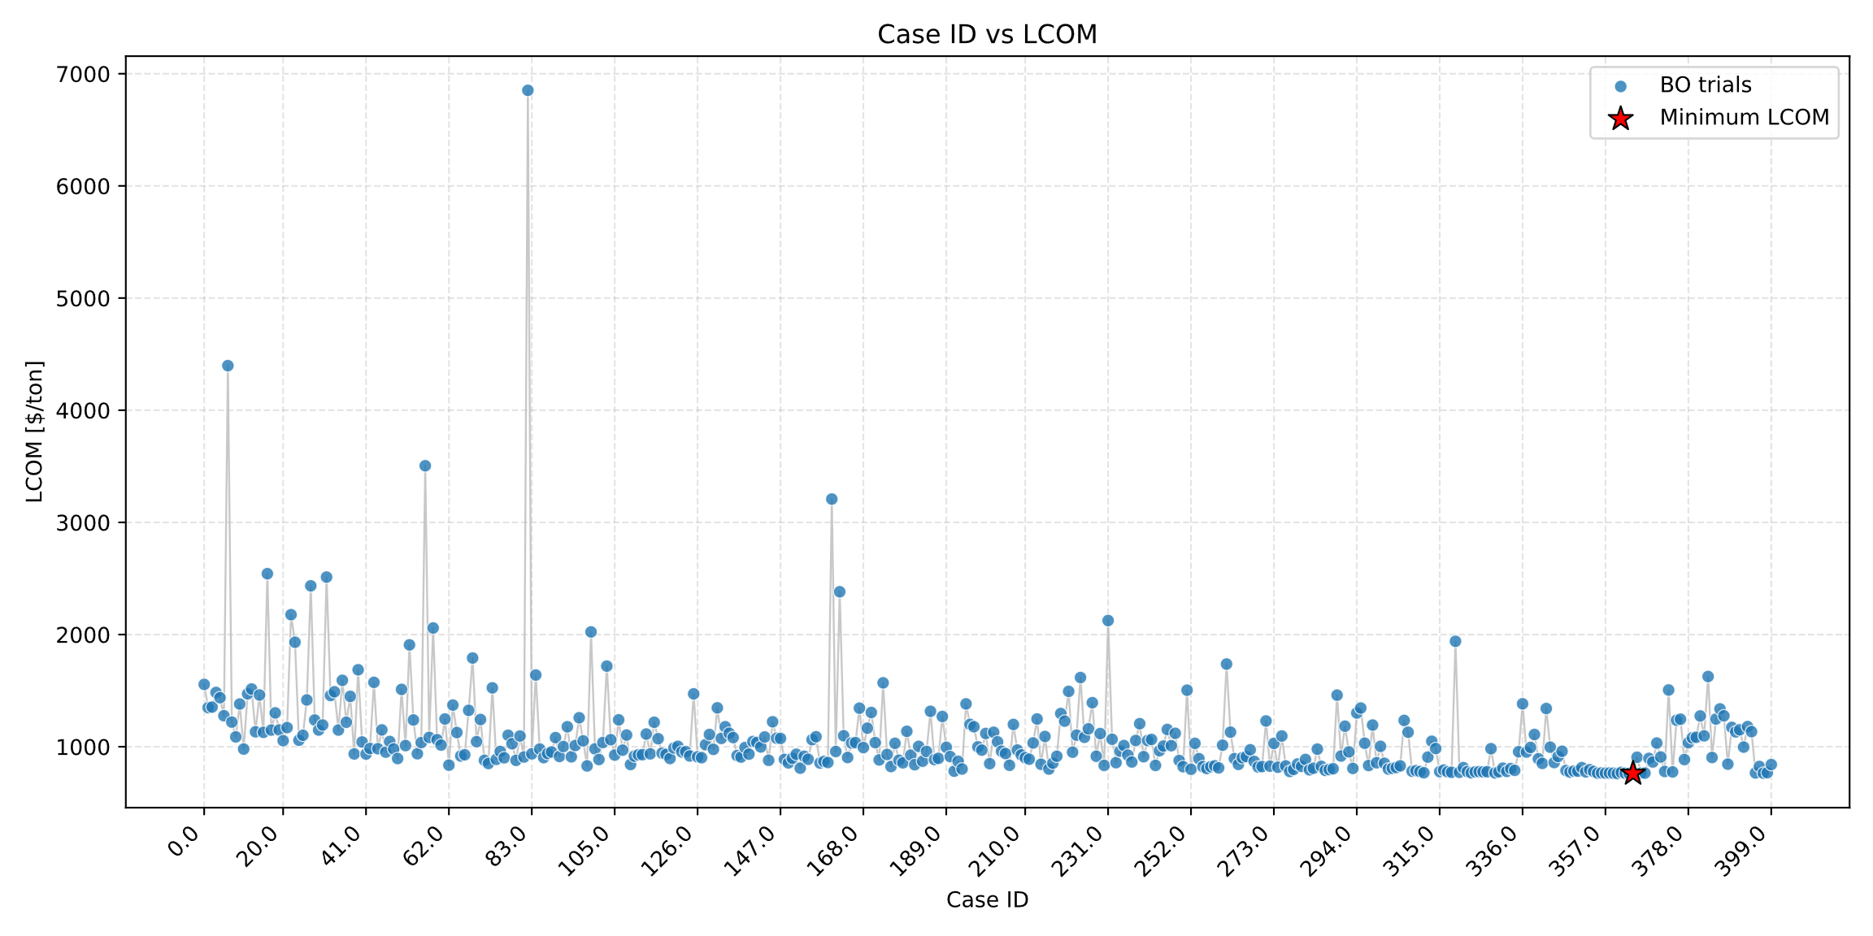
Figure 5 BO trials and their corresponding LCOM as objective variable

Optuna's hyperparameter importance tool quantifies how sensitive the objective function is to each decision variable and ranks their relative influence. The resulting plot shows that electrolyzer capacity has the greatest influence on system performance, followed by PV, ATR, WT, and BESS capacities. Other parameters have relatively negligible influence on the objective variable.

These relative importance values depend on the search range assigned to each variable. In the Level 2 optimization, the minimum and maximum bounds for each component are derived from the initial Level 1 sizing results. Rather than restricting the search to values close to these estimates, the bounds are deliberately relaxed to allow Bayesian Optimization (BO) to explore configurations that may differ substantially from the Level 1 baseline. The table below summarizes the search bounds for all variables.

Within these bounds, the objective function is largely insensitive to the capacities of BGSS, CGH2, and the generator. This low sensitivity likely explains why the best performing optimal trial selected boundary sizing values for these components: 0 MW for the generator, 0 tons for CGH2, and the higher bound of 7 tons for BGSS.
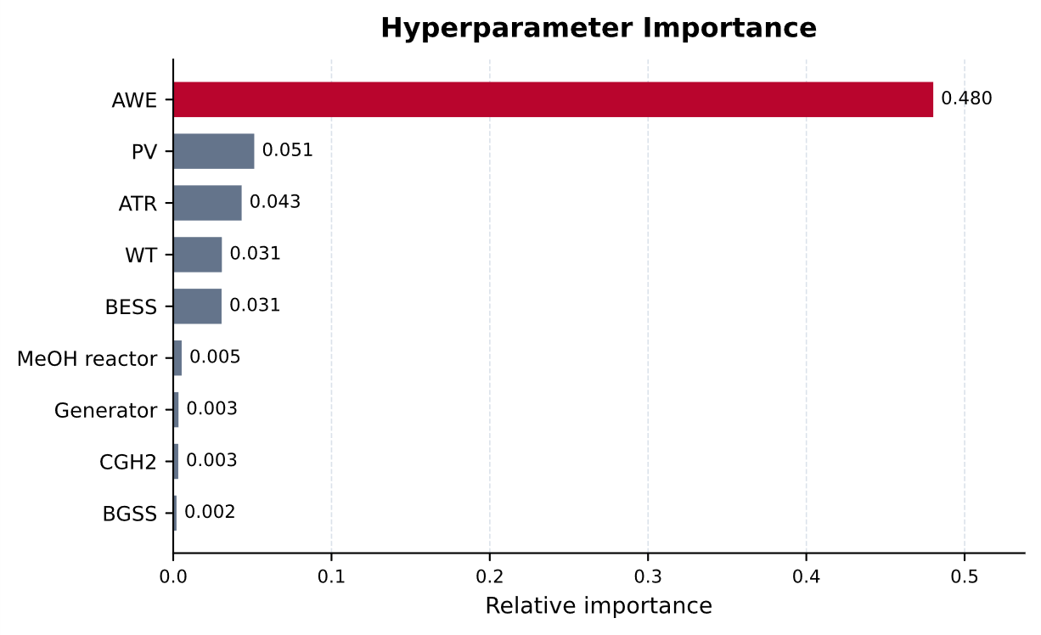
Figure 6 Optuna hyperparameter importance plot.

Table 17 BO decision variable search space.
Components | BO Search Space (All Continuous)
 | Min | Max
PV [MW] | 0 | 150
WT [MW] | 0 | 70
Generator [MW] | 0 | 5
BESS [MWh] | 0 | 200
AWE [MW] | 0 | 20
ATR [ton/year] | 5000 | 20,000
MeOH reactor (m³/year) | 20,000 | 35,000
CGH2 [ton] | 0 | 10
BGSS [ton] | 0 | 7
AD [ton/year] – Fixed anchor point | 20,000
MeOH storage [m³]– Fixed sink | 288

Given that the electrolyzer is the primary driver of the objective function, examining the sensitivity of LCOM to AWE sizing provides valuable design insights. Figure 7 illustrates this relationship, plotting the resulting LCOM response on a logarithmic scale across the evaluated AWE capacities.

The resulting curve exhibits a distinct U-shaped trajectory, with a pronounced cost minimum occurring within the 5–10 MW capacity range. This behavior confirms that integrating an electrolyzer into a hybrid BPtMeOH system achieves superior economic viability compared to a conventional, biomass-only methanol plant, provided the capacity is appropriately sized within this optimal window.
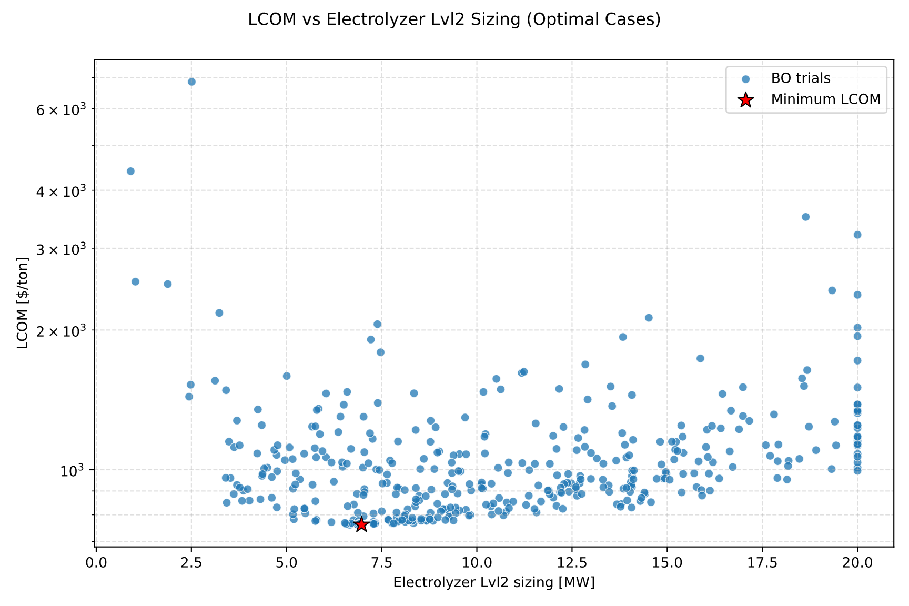
Figure 7 Log scale AWE sizing variance with the trial's LCOM result.
For the five components exhibiting the highest hyperparameter importance, the sampling trajectory of the GP sampler is illustrated in the figure below. The progression demonstrates how the Gaussian surrogate model effectively balances exploration and exploitation, continuing to sample alternative sizing values for these components even after several hundred trials. Simultaneously, a clear bias toward exploiting high-performing regions becomes evident as the search advances, with sampling clustering around specific capacity ranges.

While extending (or shrinking) the search space and increasing the total trial budget could potentially drive LCOM down further, Level 2 already achieves a performance benchmark superior to Level 1. Consequently, further exhaustive fine-tuning lies beyond the intended scope of this work.
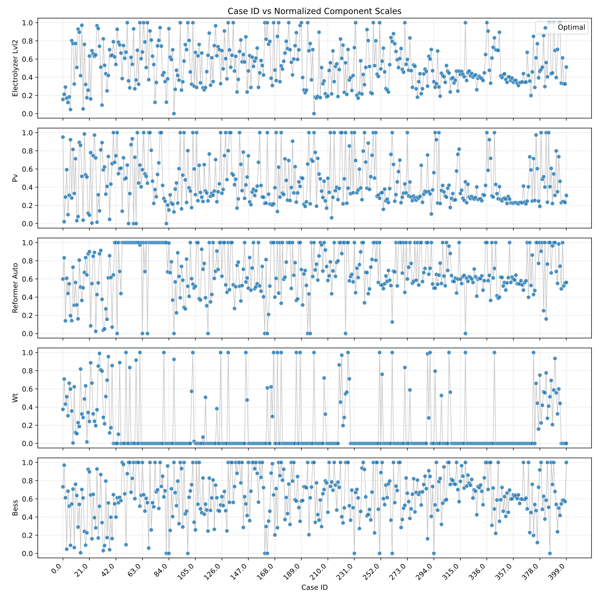
Figure 8 BO component scales evolution throughout the 400 trials budget.

Level 1 vs Level 2: Techno-economic comparative analysis
Level 1 and level 2 results have been simulated as fixed layout under non-linear economic of scale to be compared under identical cost assumption based on the selected KPIs. Table 18 and 19 below summarize the results for both different methodology approaches.
Table 18 Level 1 vs level 2 KPIs under realistic non-linear economic of scale assumption.
KPIs | Level 1 | Level 2
LCOM result [$/ton] | 779 | 761.2
MeOH produced [ton] | 19,426.7 | 18,157.1
Annualized CAPEX [M$] | 7.97 | 7.1
OPEX [M$] | 4.03 | 3.6
Clipped Energy [%] | 7.7 | 14.2

Table 19 Design sizing results for level 1 and level 2
Components | Level 1 | Level 2
PV [MW] | 38.11 | 34.28
WT [MW] | 0 | 0
Generator [MW] | 0 | 0
BESS [MWh] | 141.43 | 119.2
AWE [MW] | 9.16 | 6.97
ATR [ton/year] | 12,208.2 | 13,022.4
MeOH reactor (m³/year) | 26,583.8 | 23,408.8
CGH2 [ton] | 0 | 0
BGSS [ton] | 0 | 7
AD [ton/year] – Fixed anchor point | 20,000 | 20,000
MeOH storage [m³]– Fixed sink | 288 | 288

Under non-linear economic of scale assumption, level 2 proves to output a superior LCOM result in comparison to level 1. The way in which it does it does not involve producing more methanol, rather it settles with a lower yearly yield that proves to be more financially efficient in producing methanol per unit. However, this is not true for the clipped energy metrics as level 2 wastes two time more energy than level 1 relative to its production capacity.

In terms of sizing, both level 1 and level 2 settle with a similar PV capacity as the sole electricity producer, deciding in not to choose either WT nor Generator. Level 2 downscales the other components except ATR, which is slightly larger than its level 1 counterpart.

The figure below shows the comparison of the two methodologies under the two assigned case studies: Figure 9 shows the performance of both level 1 and level 2 under linear and non-linear economic of scale while Figure 10 presents the layout of both approaches under the baseline bad weather contrasting it with a good weather scenario.
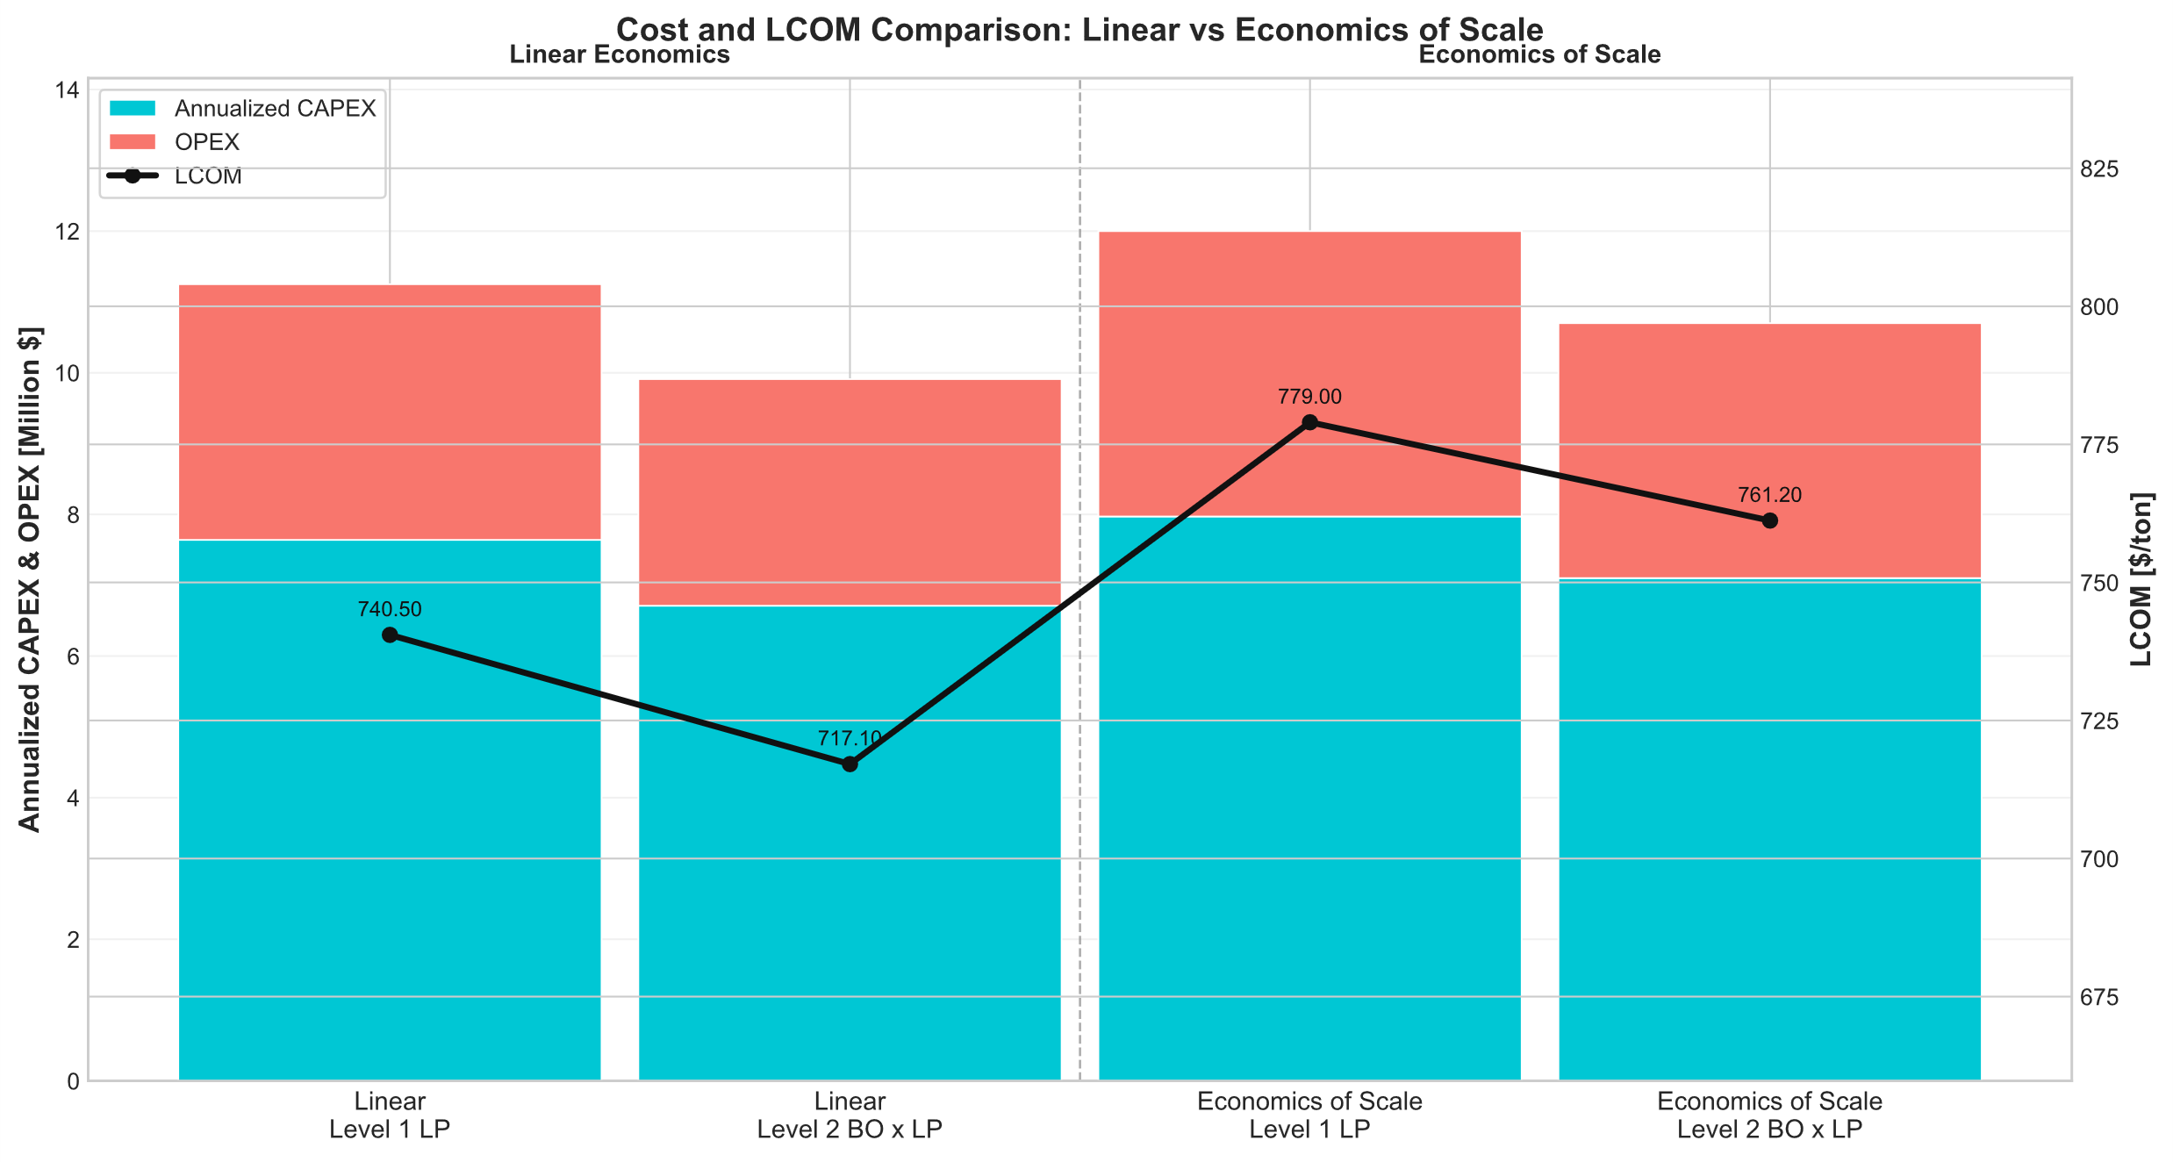
Figure 9 Level 1 vs level 2 under linear and non-linear economic of scale.

Based on Figure 9, it is evident that level 2 achieves lower LCOM in both linear and non-linear economics of scale. Since level 2 optimizes for LCOM directly, level 2 has the advantage to iterate on its trials to achieve this. On the other hand, level 1 produces more methanol but with less efficiency with respect to cost despite its ability to reach global optimum for its linear objective variable. From this comparison, it is possible to conclude that level 2 bilevel approach with Bayesian optimization is superior for non-linear objective function problem compared to an LP co-optimization of dispatch and sizing.

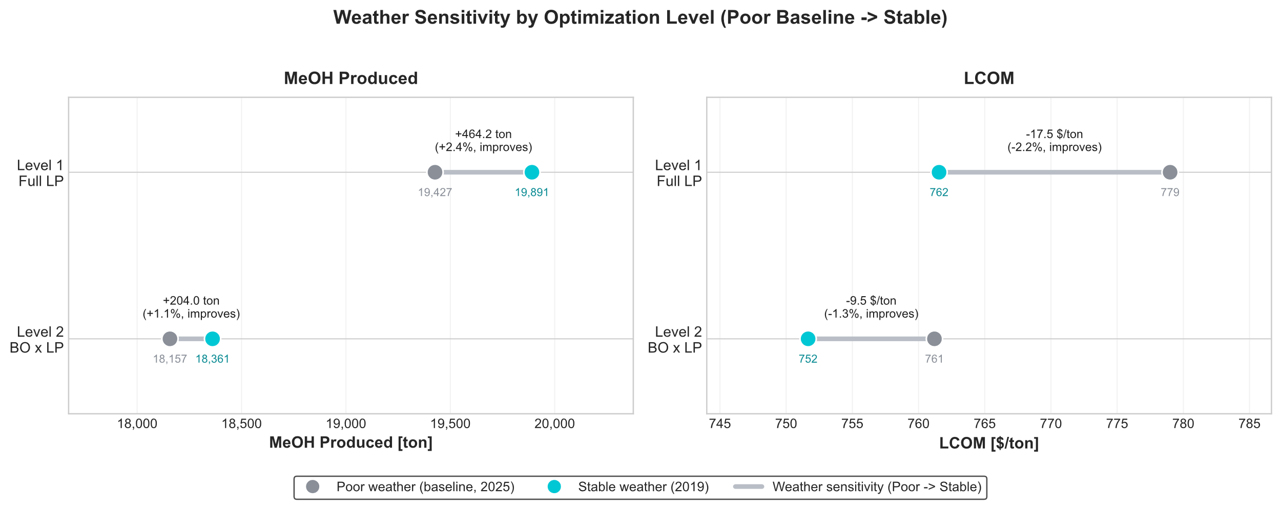
Figure 10 Differentiating weather for level 1 and level 2 results.
At the selected plant coordinates in South Africa, historical weather data reveals that 2025 yielded the lowest PV generation across the entire 2014–2025 period. To evaluate system resilience under contrasting resource availability, the baseline configuration is benchmarked against the historical best-performing year for solar PV, characterized by optimal mean power output and profile variance. Figure 10 illustrates the resulting sensitivity of LCOM and annual methanol yield across both Level 1 and Level 2 layouts under this favorable weather scenario.

For Level 1, the optimal weather conditions lead to a 2.4% increase in methanol yield, driving a 2.2% reduction in LCOM from 779 $/ton down to 762 $/ton. In contrast, the Level 2 configuration demonstrates greater robustness to weather variability: methanol yield increases by only 1.1%, resulting in a modest 1.3% cost reduction from 761 $/ton to 752 $/ton.

LP vs Reinforcement learning for optimal dispatch
In this section, the fixed layout defined in Chapter 3 is evaluated using both the LP-derived IC and an RL agent. The first subsection outlines the reconstruction and validation of the linear system within the step-function-based RL environment utilizing the IC. Subsequently, the performance of the LP representation controller with IC applied to key components is benchmarked against the RL agent trained on the linear system.

Linear Model Reconstruction
Prior to training the RL agent on the linear hybrid BPtMeOH system, it is paramount to ensure that the linear model built in oemof.solph maps one-to-one to the environment modeled for RL. This alignment is required because an RL agent cannot be trained directly on a Pyomo-based formulation defined by global constraints and an overarching objective function. Transferring the system logic into a Gymnasium step-function-based environment is therefore necessary. To verify that the dynamics are identical, the optimal dispatch trajectories from the LP solution are applied to the Gymnasium environment to confirm that the state transitions and component behaviors match exactly.

The action-owned components and their sequential evaluation order within the Gymnasium environment were defined in Chapter 3. These two structural aspects are critical for accurately reconstructing the linear model. Initially, it was assumed that controlling only two primary components, AD and AWE, would suffice to replicate system behavior, with the remaining units passively following via RBC. However, the LP benchmark reveals that this assumption fails due to operational decoupling between the components in the biogas and electricity pathways. Rather than simply trailing the upstream AD output, the dispatch trajectories of the AD, ATR, and RWGS operate with noticeable independence. This decoupling is illustrated in Figure 11: while a baseline operational relationship exists among the three units, distinct periods of decoupled operation occur, as highlighted between timesteps 2600 and 2675 as well as around timestep 2700.
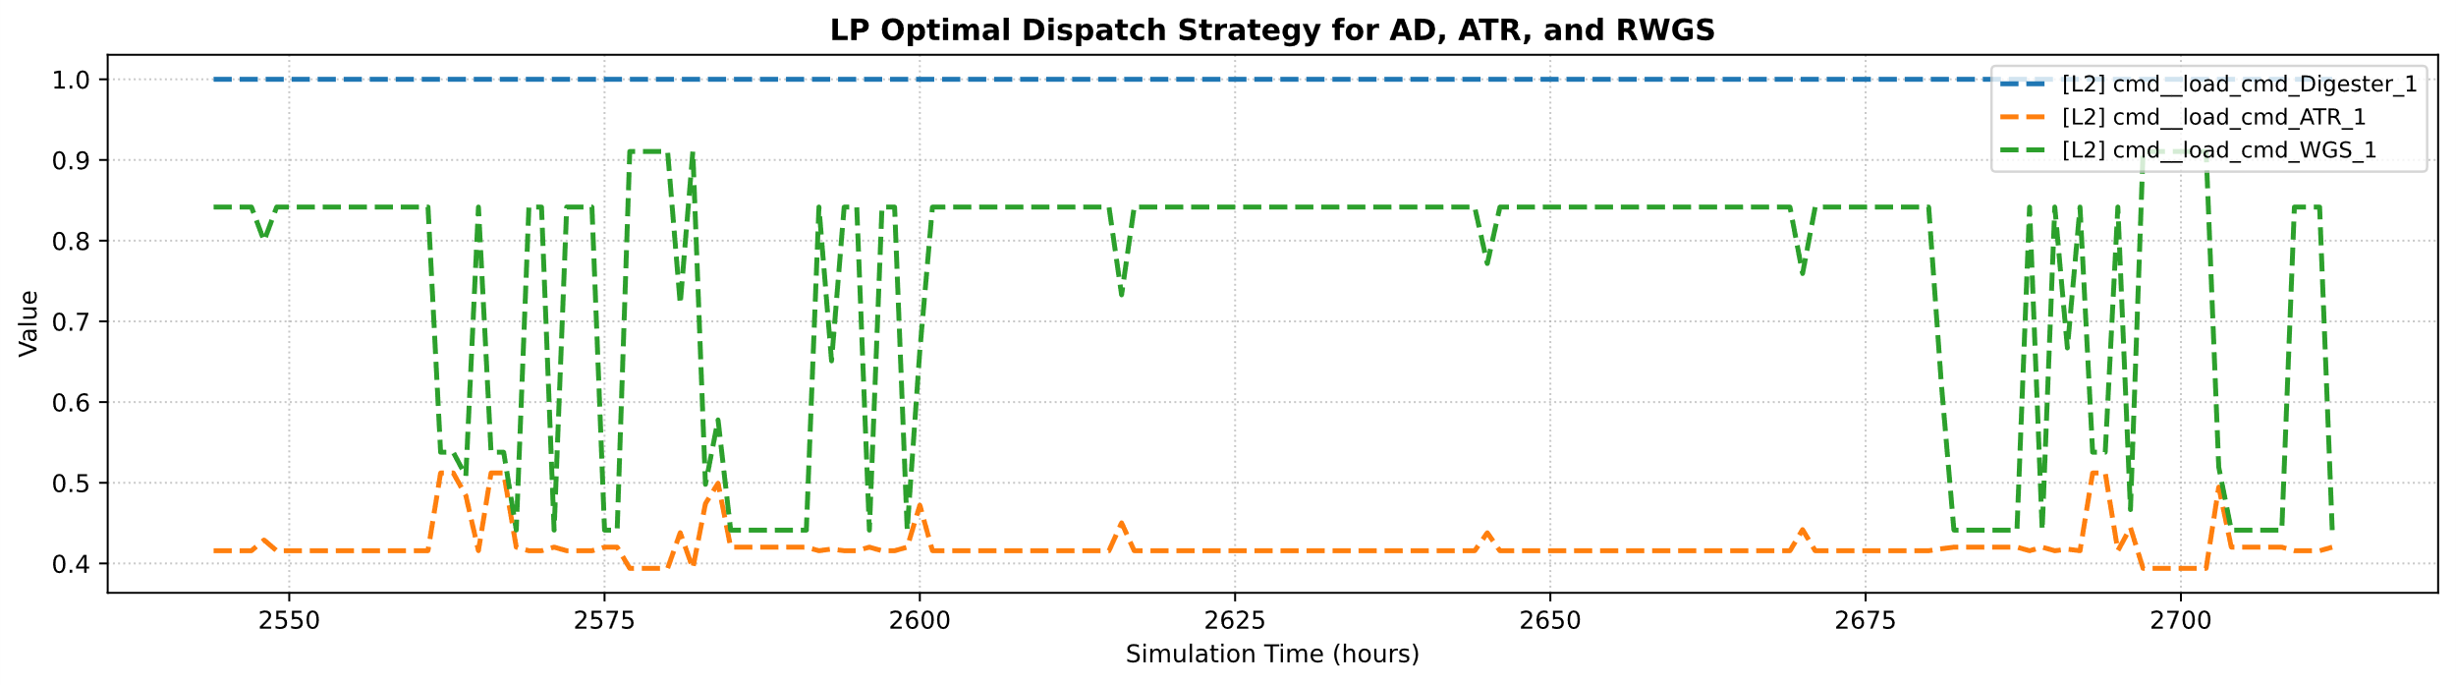
Figure 11 LP normalized commands of AD, ATR, and RWGS.

Similarly, an analogous behavior emerges within the electricity pathway among the PV, BESS, and generator. Under the LP-derived optimal strategy, the BESS and generator do not simply act as passive balancing mechanisms that self-settle in response to instantaneous surpluses or deficits on the electricity bus. Instead, their dispatch trajectories decouple from immediate net-load balancing and correlate strongly with broader fluctuations in the PV profile, exploiting the LP's perfect foresight of upcoming generation.

This behavior indicates that either the BESS or the generator must also be explicitly governed via IC. Furthermore, achieving an exact operational match requires incorporating active electricity curtailment into the control logic. A prominent example of this dynamic appears in Figure 12, where the LP optimal dispatch curtails generation ahead of time despite a low BESS state of charge (SOC).
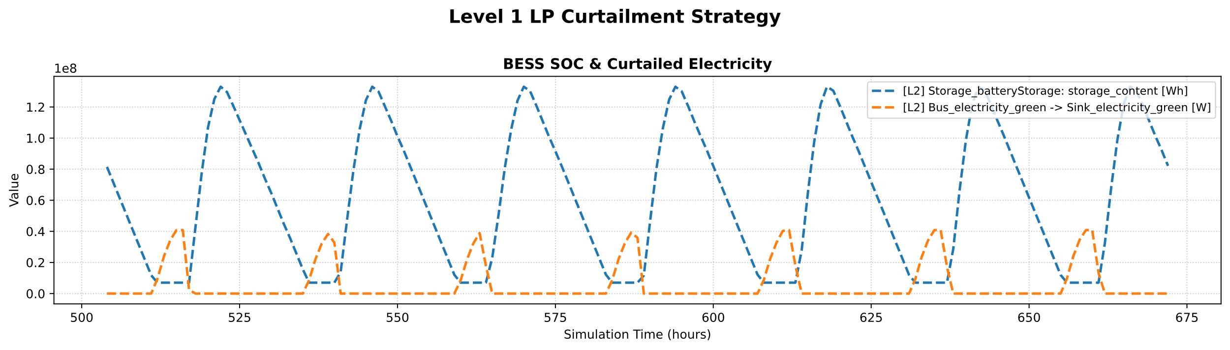
Figure 12 Electricity curtailment strategy of LP
Incorporating these key insights, the five action-owned components (ATR, RWGS, AD, AWE, and generator) were defined as outlined in Chapter 3, and the reconstructed linear system was validated against its LP counterpart. Figure 13 demonstrates this alignment. Because the storage components are positioned at the terminal stage of the sequential evaluation order, any upstream operational mismatch or mass/energy balance error would cascade down and distort the storage SOC profiles. The identical SOC trajectories between the LP solution and the LP-derived IC environment confirm that the reconstructed step-function system matches the original model dynamics. The only underlying distinction lies in the temporal indexing of the SOC states: in the Gymnasium environment, the SOC updates at the end of the current timestep $t$, whereas the LP formulation indexes the resulting state at $t+1$. This structural indexing convention accounts for the uniform one-hour (single-timestep) offset observed between the curves in Figure 13.
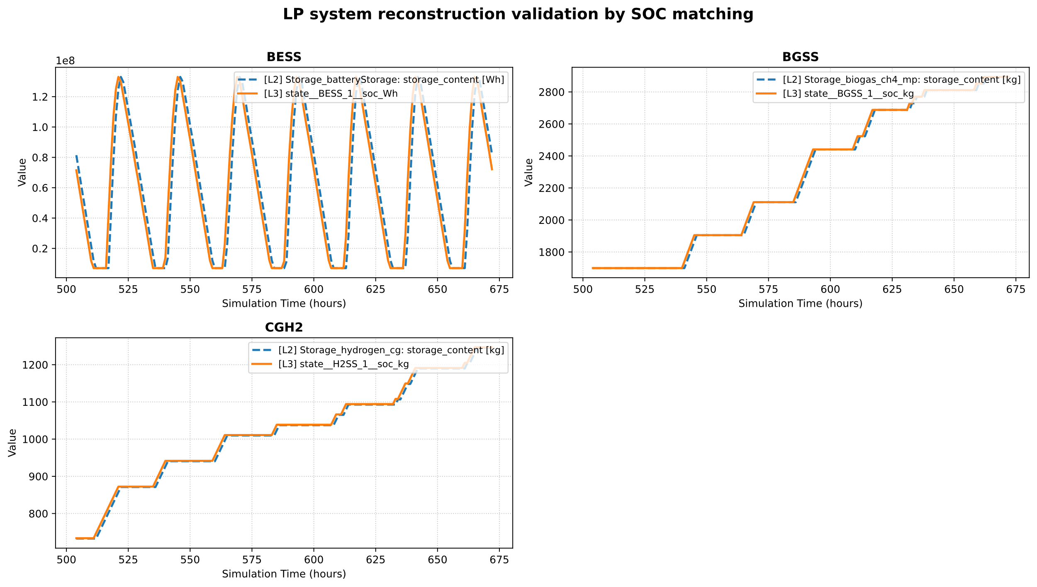
Figure 13 SOC matching between LP and IC reconstruction.

RL agent training evolution
Extensive RL training was conducted throughout this study, yielding key insights into the operational dynamics of RL agents for optimal dispatch.

Following the validation of the IC baseline in the previous section, initial RL training was executed with minimal hyperparameter tuning, followed by iterative refinements that progressively improved dispatch performance. The table below details the configuration differences between this preliminary baseline and the tailored setup adopted for the final run, with all unlisted parameters held consistent with the specifications in Chapter 3. Figures 14 and 15 illustrate how these hyperparameter modifications directly influence the resulting dispatch behavior.

Different Hyperparameters | Preliminary Run | Final run
State-of-charge penalty (BESS / BGSS / H2SS) | 1 | 15
Generator fuel penalty | Not applied | 0.005
Generator cycling penalty | Not applied | 1
RWGS CO2 penalty | Not applied | 0.0001
Terminal breach penalty | 1,000,000 | 50
MeOH (reward) | 10 | 0.015
gradient steps | 4 | 20
ent_coef | auto | auto_0.5

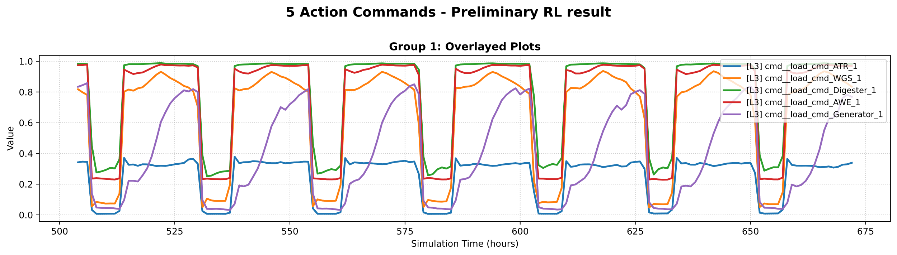
Figure 14 Preliminary RL training dispatch strategy.
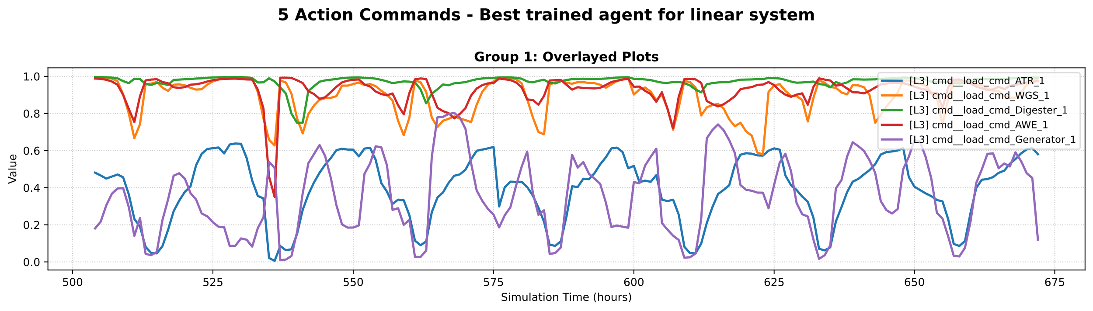
Figure 15 Final RL training dispatch strategy.
Figures 14 (preliminary) and 5 (final) illustrate the five RL action setpoints: ATR, RWGS, AD, AWE, and generator relative loads, across an identical evaluation window from hours 500 to 675. With the layout, observation space, and action bounds held constant, performance differences stem solely from the reward formulation and two optimization hyperparameters. In the preliminary run, all five actuators move in lockstep, tracing a synchronized square wave that saturates during daylight and collapses to zero at night, effectively blindly dictating the system to the PV profile. In the final run, this artificial locking phenomena disappears: the AD and ATR maintain a steady baseline feed, the RWGS modulates around it, and the AWE and generator execute decoupled dispatch schedules independent of the solar cycle.

This degeneracy stems directly from reward-scale imbalance. With a methanol weight of 10, full-load production yielded roughly $2.3×{10}^{4}$ reward units per step, whereas the only active constraint penalty (SOC violations at weight 1) contributed order-unity feedback. Because the constraint signal was four orders of magnitude smaller than the yield term, the agent faced an effectively single-objective task: maximizing instantaneous throughput by co-ramping every component with available solar power. Furthermore, the $1,000,000$terminal bus-breach penalty created a catastrophic cliff that dominated the return. Rather than exploring component trade-offs, the policy adopted a defensive, low-variance response that clamped all actuators together, the optimal mathematical response to an uncalibrated objective lacking differentiated action costs.

The final reward rebalances production yield, system feasibility, and operational costs onto a comparable numerical scale. Lowering the methanol weight to 0.015 scales the maximum step yield down to roughly 34.5 units, raising the SOC penalty weight to 15 penalizes boundary violations meaningfully, and reducing the terminal penalty to 50 converts the cliff into a proportionate deterrent. Under these bounds, co-ramping actuators with PV is penalized because it breaches BESS, BGSS, and ${\text{CGH}}_{2}$ limits. Avoiding these excursions requires operating the units against one another, producing the phase-shifted trajectories in Figure 15. Additionally, three targeted terms decorrelate the commands: a generator ramping penalty suppresses square-wave cycling, a fuel penalty separates generation from simple renewable tracking, and an RWGS ${\text{CO}}_{2}$ penalty assigns an actuator-specific cost that incentivizes further syngas production as MeOH reactor feed.

Complementing the reward engineering, hyperparameter adjustments enabled the agent to learn this multi-objective trade-off. Increasing the SAC gradient steps from 4 to 20 at a training frequency of 20 raised the update-to-data ratio from 0.2 to 1.0. This fivefold increase in replay frequency gave the critic the representational capacity to resolve individual actuator value distinctions rather than collapsing into coarse PV tracking. Simultaneously, setting the initial entropy temperature to auto_0.5 sustained exploration early in training, preventing premature convergence before the rescaled penalties took effect. Ultimately, the preliminary lockstep behavior was an artifact of an unbalanced objective and weak learning signal; rebalancing the rewards and increasing the update ratio successfully converted the agent into a coordinated, multi-variable dispatch controller.

With the final hyperparameter configuration established, the agent completed a stable training convergence, as illustrated by the reward maximization and penalty minimization profiles in Figures 16 and 17. The episodic return largely plateaus after episode 550, even as the agent continues active exploration, evidenced by the persistent high-frequency fluctuations in the raw reward signal in Figure 17. While performance gains saturate beyond this horizon under the current setup, further refinement in reward engineering or neural network architecture could potentially unlock marginal improvements.
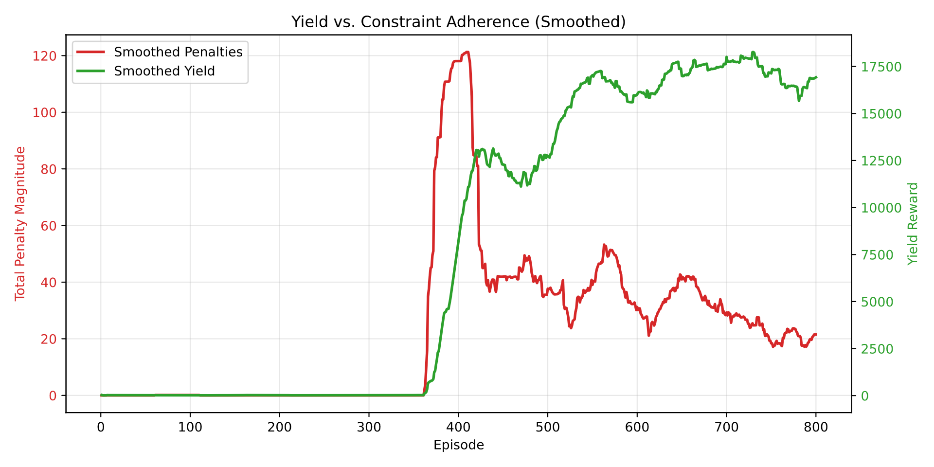
Figure 16 Penalty and reward evolution throughout training progression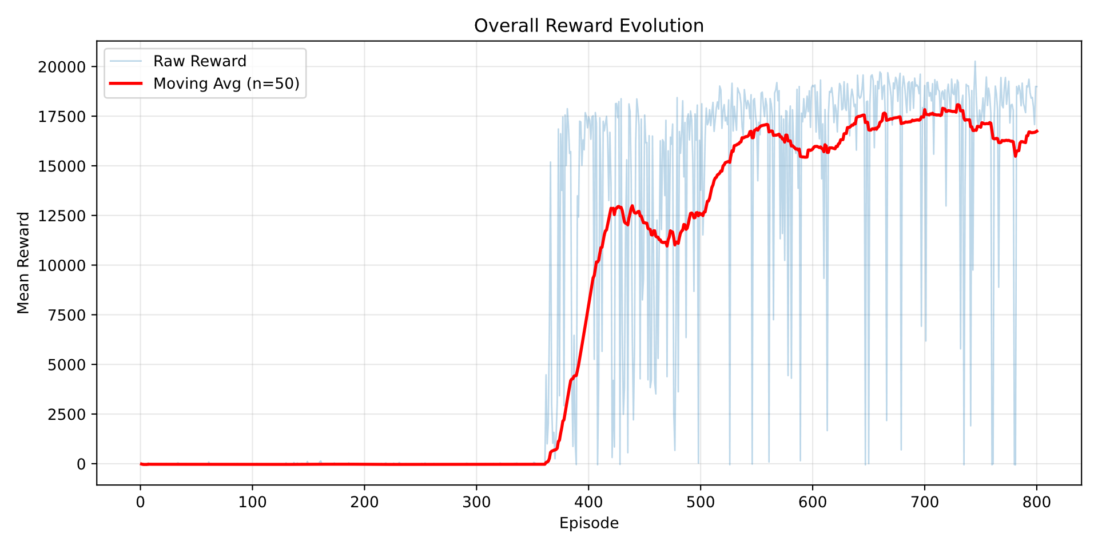
Figure 17 Reward evolution plot with raw and smoothed data.

LP-derived IC vs RL on Linear Hybrid BPtMeOH
Table 20 KPIs of IC & RL agent as controller for the linear system.
KPIs | IC controller | RL agent
LCOM result [$/ton] | 800.85 | 859
MeOH produced [ton] | 19,492 | 18,172
Annualized CAPEX [M$] | 8.5
OPEX [M$] | 3.98
Clipped Energy [%] | 28.2 | 34.5

Following the iterative enhancement of the RL agent via tailored hyperparameter tuning and reward engineering, this section evaluates the operational performance divergence between the LP-derived IC benchmark and the trained RL agent on the fixed layout. Table 20 summarizes the comparative performance across the key performance indicators.

On the linear system, the IC benchmark demonstrates superior performance across both production and economic metrics, achieving higher annual methanol output and reducing LCOM by 58.15 $/ton relative to the RL policy. This disparity originates from the performance gap of the RL agent in fully maximizing chemical synthesis capacity and maintaining optimal energy utilization efficiency.

However, this comparison must be evaluated within the context of the underlying information architecture. The IC benchmark represents an offline optimum computed with perfect foresight over the entire annual PV profile, which mathematically guarantees global optimality on the linear formulation. In contrast, the RL agent operates under causal constraints: it is trained on discrete one-month episodes and is restricted to a rolling seven-day lookahead window of the PV forecast. From this limited observation window, the agent must autonomously map the stochastic relationship between the forecasted weather features and optimal dispatch actions. Despite these operational limitations, the SAC agent successfully recovers 93.2% of the globally optimal methanol production potential, demonstrating strong policy viability under causal uncertainty.

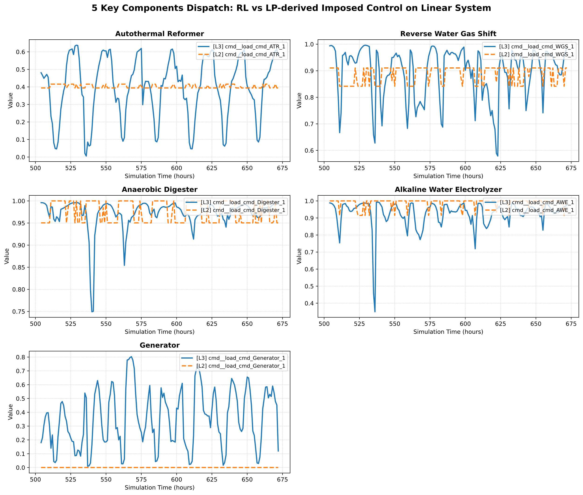
Figure 18 RL (blue) vs LP-derived IC (orange) optimal dispatch strategy.
Figure 18 above outlines the difference in how the IC and RL agent controls the action-owned components: ATR, RWGS, AD, AWE, and Generator. The five action-owned components form a single carbon-hydrogen chain, and the dispatch traces show the RL agent and the LP-derived imposed controller operating that chain in fundamentally different ways. The LP controller (orange) maintains the system along a steady economic optimum, operating the AD continuously at high capacity to maximize both the primary carbon throughput and the upstream ATR hydrogen required by the RWGS. Consequently, CO2 venting remains minimal, and the generator is kept offline to prioritize methane for reforming rather than direct combustion.

In contrast, the RL agent (blue) governs dispatch reactively on an hourly basis, diverging from the LP-derived IC baseline across three critical operational fronts: it throttles the AD feed (yielding 0.4 kt less biogas), converts less CO2 in the RWGS resulting in 7.85 kt more emissions vented, and routinely dispatches the generator for peaking rather than reserving it strictly for deficit contingencies, consuming 1.66 kt more methane as generator fuel while offsetting boiler fuel consumption by 1.86 kt as a result of less biogas and methanol production. This delta is summarized in Table 21 below.
Table 21 Main differentiator between RL and IC performance.
Differentiators | Delta (RL-IC)
MeOH Produced [kt] | -1.32
Generator Fuel Used [kt] | 1.66
Boiler Fuel Used [kt] | -1.86
Wasted CO2 from RWGS [kt] | 7.85
Digester Biogas Output [kt] | -0.4

These operational deltas can be converted into an equivalent carbon balance and benchmarked directly against the measured methanol yield gap. Because methanol is a single-carbon molecule, the 1,320 t production shortfall corresponds to a carbon deficit of:
$$Δm_{\text{C,MeOH}}=1,320×\frac{M_{\text{C}}}{M_{\text{MeOH}}}=1,320×\frac{12.011}{32.042}≈495\text{ t of carbon}$$
Equation 28
The vented RWGS CO2 represents carbon that entered the conversion train but exited unreacted due to a deficit of ATR hydrogen:
$$7,850×\frac{12.011}{44.009}≈2,142\text{ t of carbon}$$
Equation 29
Similarly, the reduced biogas throughput eliminates carbon backbone at the source. Given that the raw digester biogas is approximately 37.3% methane by mass, this reduction equates to:
$$402×0.373×\frac{12.011}{16.043}≈112\text{ t of carbon as unproduced }{\text{CH}}_{4}$$
Equation 30
The additional generator fuel directly diverts methane carbon into combustion:
$$1,660×\frac{12.011}{16.043}≈1,243\text{ t of carbon}$$
Equation 31
However, this diversion is largely compensated by the concurrent reduction in boiler fuel, yielding a net combustion balance of -200 t of net fuel. Consequently, the real economic penalty of running the generator is not the gross carbon combustion, but the fact that it consumes high-value methane to produce electricity that abundant that renewable generation could have otherwise provided.

Summed across the channels that permanently remove carbon from methanol synthesis, the vented CO2 and unproduced biogas alone account for:
$$2,142+112≈2,254\text{ t of carbon}$$
Equation 32
This gross figure is more than four times the 495 t carbon deficit represented by the yield gap, and adding the generator fuel diversion widens this margin further. These diversion channels are therefore individually and jointly sufficient to account for the entire 6.8% yield shortfall. The realized production deficit is smaller than this gross carbon diversion because the generator provides useful power, the lower boiler duty partially restores the plant thermal balance, and the unreacted CO2 could not have been converted without additional stoichiometric ATR hydrogen. Fully converting this vented stream would have required around 360 t of additional ATR hydrogen. This additional hydrogen demand would have required a higher biogas throughput and reforming rate than the RL agent scheduled.

Crucially, this hydrogen deficit, the reduced biogas feed, and the frequent generator dispatch are not structural limitations of the plant hardware, but RL dynamic resource allocation over time. The LP controller operates under identical physical constraints yet closes the performance gap through perfect foresight. Knowing future generation and demand profiles over the annual horizon, the LP controller maintains high AD throughput to bank both carbon and RWGS feedstocks, reserves methane exclusively for reforming, and schedules electrolysis to absorb renewable generation that would otherwise be lost. This explains why the LP controller achieves a lower curtailment rate of 28.2% compared to 34.5% for the RL agent. Lacking lookahead capability, the RL agent relies on locally biased decisions (such as burning methane and throttling the AD during renewable deficit) that prove globally suboptimal.
The storage state-of-charge trajectories in Figure 19 illustrate this foresight disparity directly. For the BESS, both controllers exhibit nearly identical diurnal cycling slaved to the common PV profile, showing that electrical storage is not where policy behavior diverges. Instead, the divergence concentrates in the slower chemical buffers. Under the LP controller, both hydrogen and biogas inventories follow a smooth staircase trajectory across the evaluation window, climbing from roughly 720 to 1,250 kg of H2 and from 1,700 to 2,900 kg of biogas. This steady accumulation reflects proactive scheduling to meet anticipated future synthesis demands.
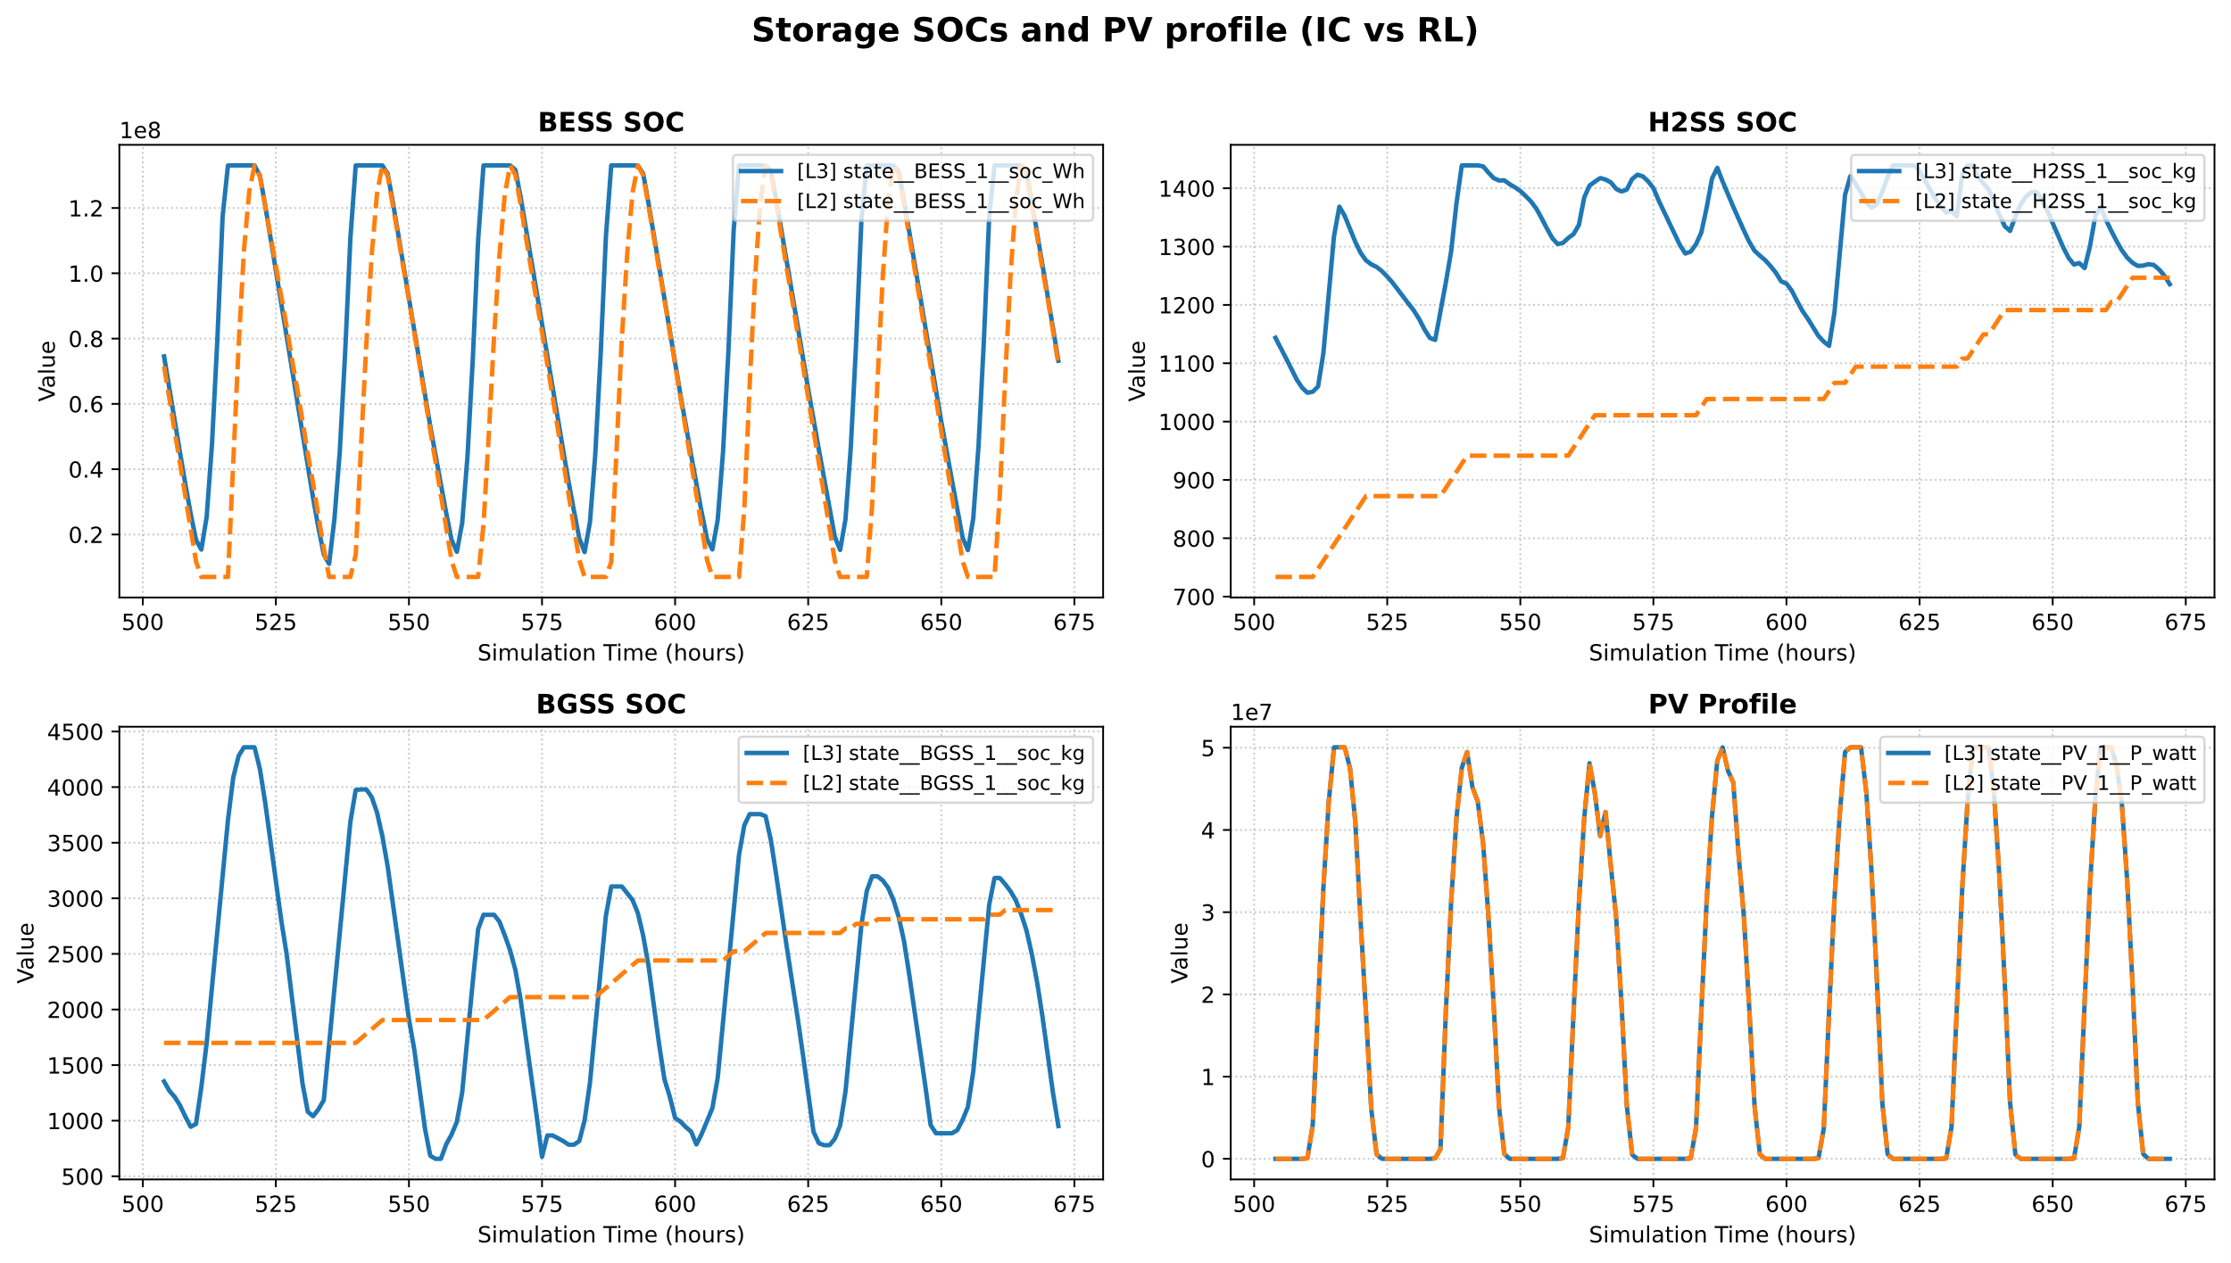
Figure 19 Operation of storage SOCs of IC vs RL with its PV input.
In contrast, the RL policy maintains a high but volatile hydrogen reserve and swings the BGSS buffer between 600 and 4,300 kg, driving it repeatedly toward lower boundary limits. These near-empty BGSS coincide with periods when the ATR is starved of feedstock, decreasing synthesis throughput and triggering the CO2 venting quantified above.

This comparison clarifies the fundamental operational difference between the two controllers: the LP benchmark manages storage inventories as a forward-looking capacity budget, whereas the causal RL agent manages them reactively against instantaneous renewable availability. This reactive buffer dispatch drives the 6.8% yield gap. Introducing a further explicit reward incentive such as for steady AD throughput and expanding the observation window with rolling lookahead horizons could potentially represent the primary control levers for recovering this performance gap.

High-fidelity non-linear system
To understand a bit more on how these two different control optimization approaches work on a more realistic system, a higher fidelity modelling of a CGH2 and AWE has been introduced to the hybrid BPtMeOH Gymnasium model. With the new high-fidelity model that embodies realistic non-linear behavior, the IC and previous linear RL agent have been deployed again to see how they manage non-linear systems. Figure 20 shows how IC performs on this high-fidelity model.
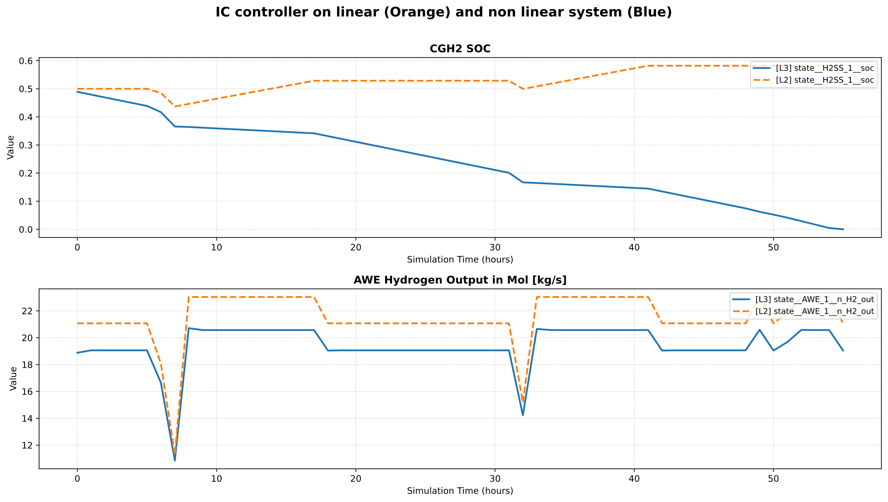
Figure 20 Plot of higher fidelity CGH2 SOC and AWE molar hydrogen output [kg/s] with IC.
The IC benchmark completed only 56 operational steps before terminating prematurely due to an infeasible deficit on the high-pressure hydrogen bus. This failure stems directly from the non-linear conversion characteristics of the high-fidelity AWE model, where operational efficiency degrades at high part-load ratios relative to the constant-efficiency linear assumption. Because the physical electrolyzer produced less hydrogen than the linear LP schedule anticipated, the non-linear ${\text{CGH}}_{2}$ buffer was rapidly depleted to its minimum SOC limit to cover the shortfall, ultimately failing to prevent system breakdown.

This immediate failure highlights the structural rigidity of the LP-derived IC approach. Because the control trajectory is predetermined offline based on idealized linear equations, it possesses zero operational adaptability to unmodeled system dynamics, plant degradation, or plant-model mismatches. Furthermore, re-optimizing the IC schedule for the high-fidelity plant is mathematically intractable within this framework, as LP solvers cannot directly accommodate the non-linear, non-convex formulation of the detailed unit models.

Conversely, the agent trained on the linear system demonstrated substantially greater operational robustness, completing 8,335 timesteps before terminating near the end of the annual horizon due to an AC electricity bus shortage. Figure 21 illustrates the dispatch trajectories of the ${\text{CGH}}_{2}$, AWE, PV, and BESS SOC preceding this terminal step. Across the evaluation period, the operational profiles of the ${\text{CGH}}_{2}$ and AWE on the high-fidelity system closely mirror those observed in the linear environment, differing primarily in local magnitude. A similar consistency appears in the BESS SOC trajectory, where policy behavior remains largely aligned between the linear and high-fidelity environments, with deviations emerging primarily during extended low-PV periods where non-linear losses compound, driving the non-linear SOC below its linear counterpart, resulting in the AC bus shortage.

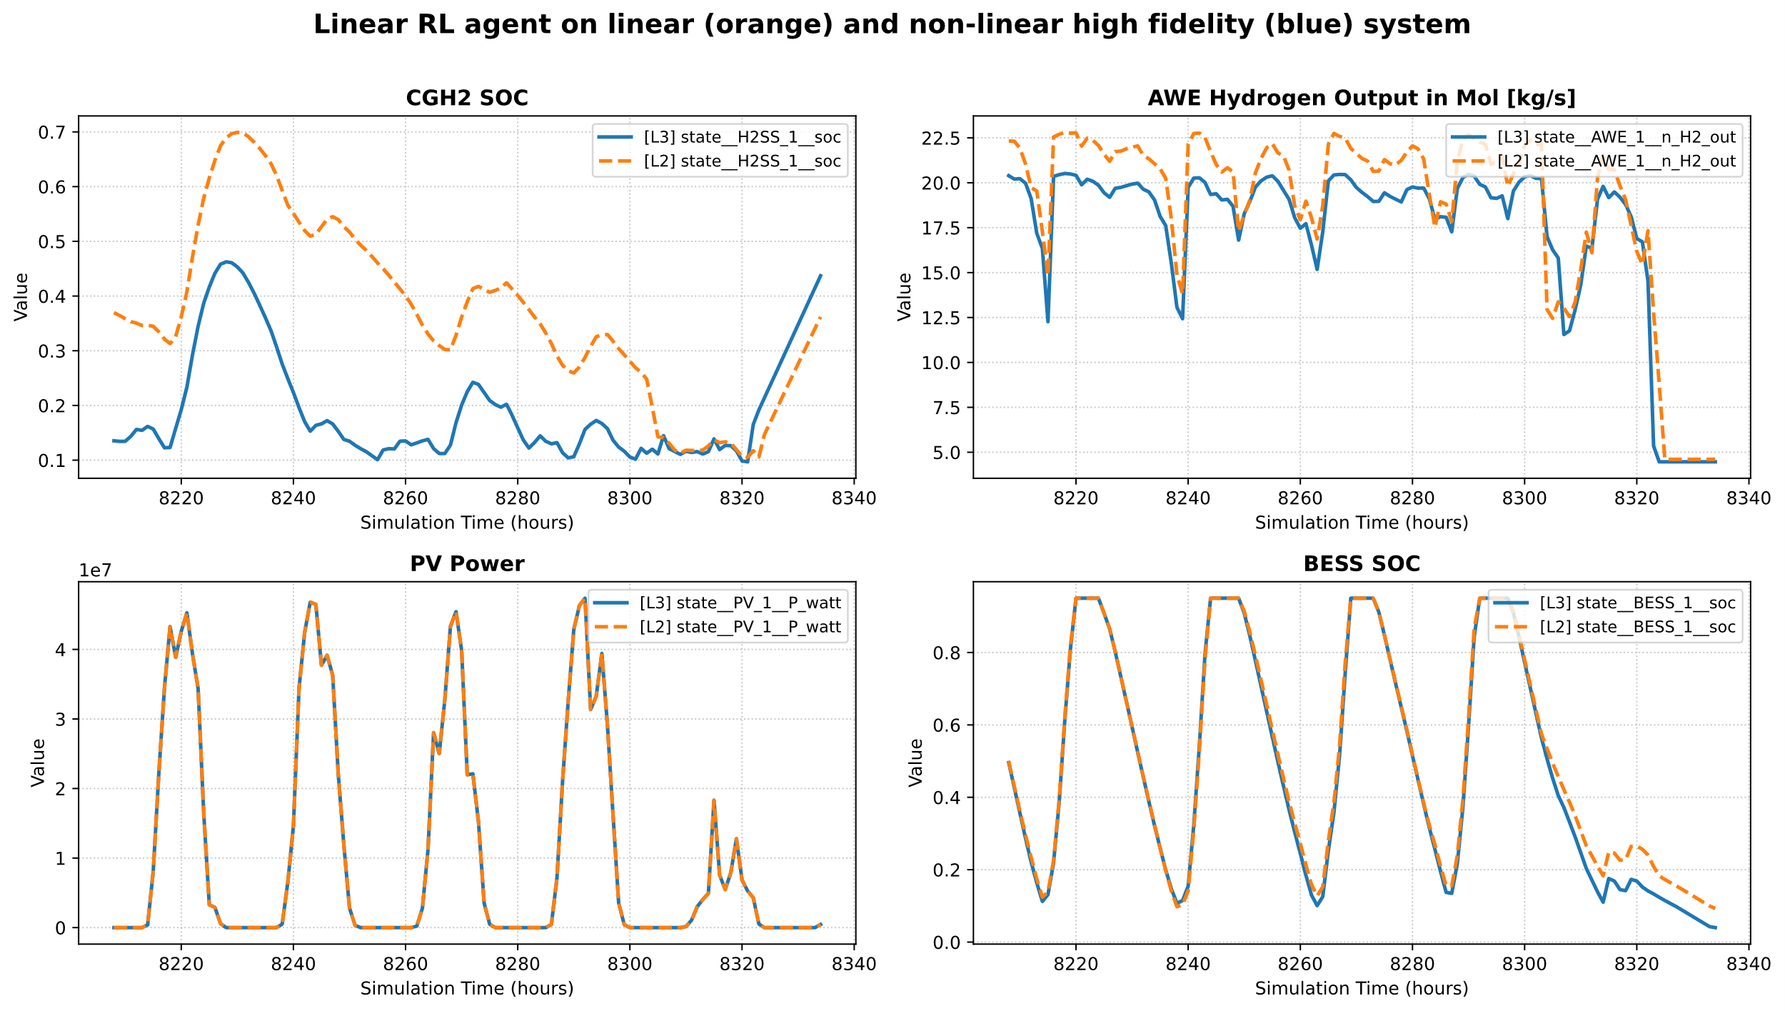
Figure 21 Linear RL agent on linear and high fidelity system.
Since the RL agent is explicitly trained to avoid hydrogen storage depletion below 5% SOC and eliminate bus balance violations via gradient-based and constant terminal penalties, the policy successfully averts early hydrogen shortages and prevents premature termination. Over an extended operating horizon, however, cumulative modeling discrepancies aggregate and propagate into the electrical network. The non-linear conversion characteristics of the AWE and detailed storage dynamics introduce shifting electrical demand profiles that diverge from the idealized linear environment seen during training.

Despite the penalty mechanisms designed to deter boundary excursions and maintain feasibility, the compounding plant-model mismatch eventually forces an unrecoverable deficit after thousands of successful operational steps. While scaling up the penalty coefficients could enforce stricter feasibility margins, doing so risks distorting the objective landscape and penalizing methanol synthesis throughput, as observed during prior reward tuning.

Crucially, unlike the LP-derived IC framework, which remains strictly bound by linear formulations, the RL paradigm is model-agnostic. This fundamental flexibility allows the agent to be retrained directly on the high-fidelity environment to internalize non-linear system dynamics without requiring structural mathematical simplifications.

With the same hyperparameters, the RL agent has been retrained on the high-fidelity model, and the operational dispatch result example is presented in Figure 22 as the retrained RL agent is contrasted with the linearly trained RL agent.

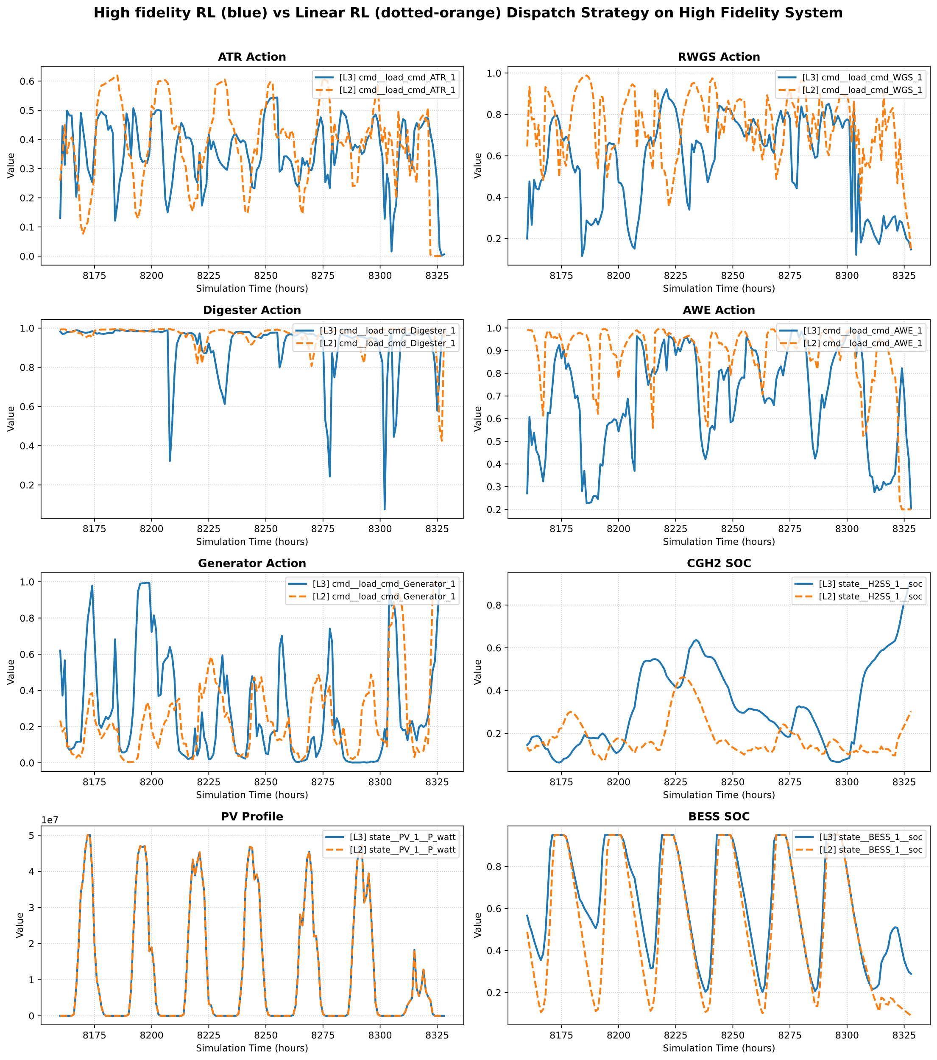
Figure 22 Retrained high fidelity RL vs linear RL on high fidelity model.

The decisive difference between the two policies lies in overall operational survival. When evaluated on the high-fidelity plant, the agent trained on the linear model terminates prematurely at simulation hour 8,335, whereas the retrained high-fidelity agent successfully completes the full annual horizon to hour 8,758. To ensure an unbiased comparison between a truncated run and a complete execution, all operational averages reported in Table 22 below are evaluated strictly over the common overlapping window of 8,335 hours. This early termination represents a definitive dispatch failure. During its final operational hours, the linear agent continuously depletes the BESS down to its 0.04 boundary floor, and once this reserve is fully exhausted, the AC electricity bus collapses into an unrecoverable deficit of approximately 409 kW.
Table 22 Operational Averages calculated on common horizon baseline (identical x axis: 8,335 steps ).
Component Actions | RL (L3: High fidelity) | RL (L2: Linear) | Delta (L3-L2)
AD | 0.938 | 0.973 | -3.5%
ATR | 0.373 | 0.393 | -5.1%
RWGS | 0.628 | 0.737 | -14.8%
AWE | 0.724 | 0.848 | -14.6%
Generator | 0.302 | 0.369 | -18.2%
BESS SOC | 0.639 | 0.563 | +13.4%
H2SS SOC | 0.465 | 0.224 | +107.7%

The clearest evidence of a mistrained value function in the linear policy emerges immediately prior to this breakdown. Over a nighttime sequence with zero PV generation, the BESS discharges from 0.08 to 0.04. Rather than shedding non-critical electrical loads to preserve bus stability, the linear agent continues directing power toward hydrogen compression, driving the CGH2 SOC upward from 0.33 to 0.44 even while the generator command is already fully saturated at 1.0. The policy allocates scarce electricity to hydrogen storage at the exact moment it should prioritize defending the AC bus balance, an artifact inherited from its linear training environment where storage dynamics carried an artificially lower operational penalty.

The underlying driver behind these diverging behaviors is the electrolyzer dispatch strategy. Over the common 8,335-hour horizon, the retrained agent operates the AWE at a lower mean load factor of 0.724 compared to 0.848 for the linear policy, representing a 14.6% reduction in average operating setpoint. Despite this lower utilization, the retrained agent more than doubles the accumulated hydrogen reserve, maintaining an average CGH2 SOC of 0.465 against 0.224 for the linear agent, an increase of 107.7%. Consequently, while the retrained policy generates less gross hydrogen over time, it banks a noticeably larger operational buffer, directly exploiting the load-dependent efficiency curve of the high-fidelity AWE stack where cell voltage climbs along the non-linear polarization curve as current rises while molar hydrogen production remains fixed by Faraday's law as described in Equation 17 in Chapter 3, where the linear agent operates, is exactly where each additional unit of hydrogen is most expensive, so the retrained agent throttles the stack onto its efficient region.

The carbon conversion chain is likewise downscaled, though modestly and in a coordinated manner. Average setpoints for the AD, ATR, and RWGS decrease by 3.5%, 5.1%, and 14.8%, respectively. Because these units do not consume electricity directly and the RWGS is supplied by ATR syngas rather than electrolytic hydrogen, the three stages operate as an interconnected train. The retrained agent maintains this pathway at a lower, smoother baseline, whereas the linear policy enforces the higher throughput that was optimal only under constant-efficiency assumptions.

Contrary to the impression given by the isolated pre-failure window, the retrained agent utilizes the generator less over the full horizon, recording a mean setpoint of 0.302 compared to 0.369 for the linear policy, an 18.2% reduction. The linear agent's late saturation to 1.0 represents a reactive, emergency attempt to arrest bus collapse rather than a deliberate strategy, which ultimately fails because the BESS is already depleted to its floor. Instead of burning additional fuel, the retrained agent secures operational survival through proactive inventory management, sustaining a higher mean BESS SOC of 0.639 against 0.563.

These operational disparities trace directly to the plant-model mismatch during training. The linear policy was optimized assuming fixed conversion yields and flat round-trip storage efficiencies, causing its learned value function to overlook both the electrochemical overpotentials of the AWE at elevated current densities and the pressure-dependent parasitic loads of the hydrogen compressor in Equations 17 and 20, respectively.

When deployed without adaptation, the linear policy maintains the AWE and carbon conversion chain at excessively aggressive setpoints, ultimately entering the seasonal renewable trough with inadequate inventory buffers. In contrast, by internalizing these non-linear dynamics during training, the retrained agent operates the electrolyzer within its high-efficiency regime and accumulates larger hydrogen and battery reserves. This proactive management maintains feasible AC bus balances throughout the full annual horizon, successfully avoiding the boundary depletion and terminal failure that occurs to the linear policy.
Table 23 KPIs comparison between IC, linear RL, and high fidelity RL (high fidelity system)
KPIs | IC (Linear sys.) | RL (Linear sys.) | RL (High-fidelity sys.)
LCOM result [$/ton] | 800.85 | 859 | 962.16
MeOH produced [ton] | 19,492 | 18,172 | 16,224
Annualized CAPEX [M$] | 8.5
OPEX [M$] | 3.98
Clipped Energy [%] | 28.2 | 34.5 | 42.8

Table 23 reveals the inherent optimism embedded in the linear formulation under both control frameworks. The LCOM increases from 800.85 $/ton for the IC benchmark on the linear system to 859.00 $/ton for the RL controller on the same linear plant, and escalates further to 962.16 $/ton once evaluated on the high-fidelity system, representing an overall cost increase of roughly 20%. Concurrently, annual methanol output drops from 19,492 to 18,172 and finally to 16,224 ton, corresponding to a cumulative production loss of approximately 17%. Because the linear RL and high-fidelity RL setups share identical hyperparameters and training architecture, the transition between the final two cases directly isolates the impact of non-linear component physics. This 12% cost escalation and 11% yield reduction are directly attributable to physical effects absent in the simplified formulation, confirming that the linear model overstates achievable techno-economic performance.

Clipped energy climbs from 28.2% to 34.5% and ultimately to 42.8%, functioning as a clear metric of unutilized energy capacity. The high-fidelity plant serves as an ineffective energy sink especially during surplus generation hours. Since AWE efficiency degrades at elevated operating loads along the non-linear polarization curve, pushing the stack toward full capacity yields diminishing marginal hydrogen per kilowatt. Consequently, the retrained agent absorbs approximately 15% less electricity through the AWE, while the storage charging path incurs additional pressure-dependent compressor power. With more renewable power curtailed and less energy channelled into synthesis, methanol output per unit of installed capacity declines, exposing how the linear model's constant efficiencies and idealized storage understate energy curtailment.

A necessary methodological distinction is that the three evaluations vary across both controller paradigm and system fidelity, meaning only the final two columns provide a strictly controlled comparison. The IC benchmark should therefore be interpreted as an idealized theoretical reference rather than a direct operational equivalent. Nevertheless, the primary takeaway is the directionality of the results: every key performance indicator degrades as physical modelling fidelity increases. This consistent degradation across economic, chemical, and electrical metrics demonstrates that the performance gap is structural rather than an artifact of control tuning. High-fidelity modelling is therefore essential for realistic techno-economic assessments, with linear representations serving strictly as an optimistic upper bound.

Conclusions
A comprehensive two-phase techno-economic framework was developed to evaluate joint sizing and operational dispatch methodologies for a hybrid biomass Power-to-Methanol (BPtMeOH) plant. The first phase benchmarked monolithic linear programming (LP) co-optimization (Level 1) against a bi-level Bayesian Optimization and LP architecture (Level 2). The second phase conducted an operational dispatch comparison between an LP-derived ideal controller (IC) and a Soft Actor-Critic (SAC) reinforcement learning agent across both an idealized linear formulation and a high-fidelity system incorporating non-linear component physics.

The Phase 1 comparison demonstrated the inherent limitations of monolithic LP formulations in capturing non-linear economic objectives. By decoupling design sizing from operational scheduling, the Level 2 bi-level framework achieved superior levelized cost of methanol (LCOM) outcomes under both linear and non-linear economies-of-scale CAPEX assumptions, while also exhibiting greater robustness across diverse annual weather scenarios. Furthermore, the global sensitivity and hyperparameter importance analysis within Level 2 quantitatively isolated how individual component capacities drive LCOM variance. While these findings validate the efficacy of bi-level optimization for capital allocation, they remain specific to the investigated plant topology and should be carefully benchmarked before generalizing across alternative Power-to-X configurations.

The Phase 2 dispatch evaluation was executed across two progressive stages: a linear Gymnasium environment calibrated to mirror the LP system, and a high-fidelity environment incorporating non-linear, non-convex dynamics for the alkaline water electrolyzer (AWE) and compressed hydrogen storage (CGH2). In the linear stage, the causal SAC agent recovered 93.2% of the global optimal methanol yield established by the offline LP benchmark, demonstrating strong policy viability despite operating without perfect weather foresight. In the high-fidelity stage, the comparative deployment exposed the operational brittleness of the open-loop LP schedule, which terminated prematurely due to unmodeled efficiency losses. Conversely, the model-agnostic RL agent demonstrated greater adaptability, while revealing that the idealized linear formulation acts as an overly optimistic upper bound that understates energy curtailment and overstates plant synthesis potential.
These outcomes highlight clear pathways for future research. Expanding physical modeling depth across the entire plant balance-of-plant would provide a more complete assessment of how non-linear thermodynamics affect system economics. Operationally, benchmarking online RL against a rolling-horizon model predictive controller on an industrial-grade digital twin would provide deeper insights into real-time dispatch feasibility under stochastic conditions. Finally, for capital design, directly coupling Bayesian Optimization with an RL inner loop on a high-fidelity platform offers a promising pathway toward sizing configurations that reflect physical plant operation without idealizing assumptions.

In conclusion, this thesis establishes a cohesive hierarchy of optimization methodologies where each consecutive strategy refines the preceding baseline: Level 1 co-optimization outlines the initial design space for Level 2 Bayesian search, the LP-derived IC provides an idealized benchmark for RL training, and the linear plant serves as an optimistic upper bound that motivates high-fidelity validation. While limitations regarding component fidelity boundaries, Bayesian sampling schemes, and RL hyperparameter sweeps defined the scope of this work, the frameworks presented here establish a rigorous foundation for future advances in the optimization and intelligent control of decentralized energy systems.

References
[1] S. Paltsev, J. Morris, H. Kheshgi, and H. Herzog, “Hard-to-Abate Sectors: The role of industrial carbon capture and storage (CCS) in emission mitigation,” Appl. Energy, vol. 300, p. 117322, Oct. 2021, doi: 10.1016/j.apenergy.2021.117322.
[2] J. Sousa, I. Azevedo, C. Camus, L. Mendes, C. Viveiros, and F. Barata, “Decarbonizing Hard-to-Abate Sectors with Renewable Hydrogen: A Real Case Application to the Ceramics Industry,” Energies (Basel)., vol. 17, no. 15, p. 3661, Jul. 2024, doi: 10.3390/en17153661.
[3] A. Risco-Bravo, C. Varela, J. Bartels, and E. Zondervan, “From green hydrogen to electricity: A review on recent advances, challenges, and opportunities on power-to-hydrogen-to-power systems,” Renewable and Sustainable Energy Reviews, vol. 189, p. 113930, Jan. 2024, doi: 10.1016/j.rser.2023.113930.
[4] Y. Yao et al., “A comprehensive review of optimizing hybrid renewable energy system using optimization techniques,” Engineering Science and Technology, an International Journal, vol. 78, p. 102384, Jun. 2026, doi: 10.1016/j.jestch.2026.102384.
[5] P. Wohlgenannt, S. Hegenbart, E. Eder, M. Kolhe, and P. Kepplinger, “Energy Demand Response in a Food-Processing Plant: A Deep Reinforcement Learning Approach,” Energies (Basel)., vol. 17, no. 24, p. 6430, Dec. 2024, doi: 10.3390/en17246430.
[6] R. Yokoyama, Y. Shinano, S. Taniguchi, M. Ohkura, and T. Wakui, “Optimization of energy supply systems by MILP branch and bound method in consideration of hierarchical relationship between design and operation,” Energy Convers. Manag., vol. 92, pp. 92–104, Mar. 2015, doi: 10.1016/j.enconman.2014.12.020.
[7] S. Stavrev and D. Ginchev, “Reinforcement Learning Techniques in Optimizing Energy Systems,” Electronics (Basel)., vol. 13, no. 8, p. 1459, Apr. 2024, doi: 10.3390/electronics13081459.
[8] H. Ghiasirad et al., “LCA and exergy-economic evaluation of a biogas-to-fuels system using CO2 hydrogenation and exhaust gas recycling,” Energy Conversion and Management: X, vol. 26, p. 100897, Apr. 2025, doi: 10.1016/j.ecmx.2025.100897.
[9] A. Grimalt‐Alemany, I. V. Skiadas, and H. N. Gavala, “Syngas biomethanation: state‐of‐the‐art review and perspectives,” Biofuels, Bioproducts and Biorefining, vol. 12, no. 1, pp. 139–158, Jan. 2018, doi: 10.1002/bbb.1826.
[10] M. Scomazzon, E. Barbera, and F. Bezzo, “Alternative sustainable routes to methanol production: Techno-economic and environmental assessment,” J. Environ. Chem. Eng., vol. 12, no. 3, p. 112674, Jun. 2024, doi: 10.1016/j.jece.2024.112674.
[11] E. Moioli and T. Schildhauer, “Techno-economic-environmental assessment of the integration of power-to-X and biogas utilization towards the production of electricity, hydrogen, methane and methanol,” Sustain. Energy Fuels, vol. 7, no. 11, pp. 2690–2706, 2023, doi: 10.1039/D3SE00052D.
[12] H. Zhang, L. Wang, J. Van herle, F. Maréchal, and U. Desideri, “Techno-economic evaluation of biomass-to-fuels with solid-oxide electrolyzer,” Appl. Energy, vol. 270, p. 115113, Jul. 2020, doi: 10.1016/j.apenergy.2020.115113.
[13] A. Walther, K. Löning, and E. Reichelt, “Techno-economic assessment of the impact of electrolysis technology on power-to-methanol processes,” Int. J. Hydrogen Energy, vol. 206, p. 153394, Feb. 2026, doi: 10.1016/j.ijhydene.2026.153394.
[14] J. Brauns and T. Turek, “Alkaline Water Electrolysis Powered by Renewable Energy: A Review,” Processes, vol. 8, no. 2, p. 248, Feb. 2020, doi: 10.3390/pr8020248.
[15] S. Brynolf, M. Taljegard, M. Grahn, and J. Hansson, “Electrofuels for the transport sector: A review of production costs,” Renewable and Sustainable Energy Reviews, vol. 81, pp. 1887–1905, Jan. 2018, doi: 10.1016/j.rser.2017.05.288.
[16] S. Shiva Kumar and V. Himabindu, “Hydrogen production by PEM water electrolysis – A review,” Mater. Sci. Energy Technol., vol. 2, no. 3, pp. 442–454, Dec. 2019, doi: 10.1016/j.mset.2019.03.002.
[17] H. Ghiasirad et al., “LCA and exergy-economic evaluation of a biogas-to-fuels system using CO2 hydrogenation and exhaust gas recycling,” Energy Conversion and Management: X, vol. 26, p. 100897, Apr. 2025, doi: 10.1016/j.ecmx.2025.100897.
[18] M. Scomazzon, E. Barbera, and F. Bezzo, “Alternative sustainable routes to methanol production: Techno-economic and environmental assessment,” J. Environ. Chem. Eng., vol. 12, no. 3, p. 112674, Jun. 2024, doi: 10.1016/j.jece.2024.112674.
[19] E. Moioli and T. Schildhauer, “Techno-economic-environmental assessment of the integration of power-to-X and biogas utilization towards the production of electricity, hydrogen, methane and methanol,” Sustain. Energy Fuels, vol. 7, no. 11, pp. 2690–2706, 2023, doi: 10.1039/D3SE00052D.
[20] M. Dossow, V. Dieterich, A. Hanel, H. Spliethoff, and S. Fendt, “Improving carbon efficiency for an advanced Biomass-to-Liquid process using hydrogen and oxygen from electrolysis,” Renewable and Sustainable Energy Reviews, vol. 152, p. 111670, Dec. 2021, doi: 10.1016/j.rser.2021.111670.
[21] A. Poluzzi et al., “Flexible Power and Biomass-To-Methanol Plants With Different Gasification Technologies,” Front. Energy Res., vol. 9, Jan. 2022, doi: 10.3389/fenrg.2021.795673.
[22] E. Anetjärvi, E. Vakkilainen, and K. Melin, “Benefits of Hybrid Production of E-Methanol in Connection with Biomass Gasification,” SSRN Electronic Journal, 2022, doi: 10.2139/ssrn.4184476.
[23] H. Zhang, L. Wang, M. Pérez-Fortes, J. Van herle, F. Maréchal, and U. Desideri, “Techno-economic optimization of biomass-to-methanol with solid-oxide electrolyzer,” Appl. Energy, vol. 258, p. 114071, Jan. 2020, doi: 10.1016/j.apenergy.2019.114071.
[24] A. Poluzzi et al., “Flexible Power &amp; Biomass-to-Methanol plants: Design optimization and economic viability of the electrolysis integration,” Fuel, vol. 310, p. 122113, Feb. 2022, doi: 10.1016/j.fuel.2021.122113.
[25] A. Poluzzi et al., “Flexible Power &amp; Biomass-to-Methanol plants: Design optimization and economic viability of the electrolysis integration,” Fuel, vol. 310, p. 122113, Feb. 2022, doi: 10.1016/j.fuel.2021.122113.
[26] V. Vetter, P. Wohlgenannt, P. Kepplinger, and E. Eder, “Deep Reinforcement Learning Approaches the MILP Optimum of a Multi-Energy Optimization in Energy Communities,” Energies (Basel)., vol. 18, no. 17, p. 4489, Aug. 2025, doi: 10.3390/en18174489.
[27] P. Wohlgenannt, S. Hegenbart, E. Eder, M. Kolhe, and P. Kepplinger, “Energy Demand Response in a Food-Processing Plant: A Deep Reinforcement Learning Approach,” Energies (Basel)., vol. 17, no. 24, p. 6430, Dec. 2024, doi: 10.3390/en17246430.
[28] M. Thirunavukkarasu, Y. Sawle, and H. Lala, “A comprehensive review on optimization of hybrid renewable energy systems using various optimization techniques,” Renewable and Sustainable Energy Reviews, vol. 176, p. 113192, Apr. 2023, doi: 10.1016/j.rser.2023.113192.
[29] H. Shengren, P. P. Vergara, E. M. Salazar Duque, and P. Palensky, “Optimal energy system scheduling using a constraint-aware reinforcement learning algorithm,” International Journal of Electrical Power & Energy Systems, vol. 152, p. 109230, Oct. 2023, doi: 10.1016/j.ijepes.2023.109230.
[30] A. Jaber, R. Younes, P. Lafon, and J. Khoder, “A Review on Multi-Objective Mixed-Integer Non-Linear Optimization Programming Methods,” Eng, vol. 5, no. 3, pp. 1961–1979, Aug. 2024, doi: 10.3390/eng5030104.
[31] B. Pirouz and F. Guerriero, “Multi-objective stochastic optimization problem: a systematic literature review,” Appl. Energy, vol. 405, p. 127237, Feb. 2026, doi: 10.1016/j.apenergy.2025.127237.
[32] S. Basnet, K. Deschinkel, L. Le Moyne, and M. Cécile Péra, “A review on recent standalone and grid integrated hybrid renewable energy systems: System optimization and energy management strategies,” Renewable Energy Focus, vol. 46, pp. 103–125, Sep. 2023, doi: 10.1016/j.ref.2023.06.001.
[33] T. Kleinert, M. Labbé, I. Ljubić, and M. Schmidt, “A Survey on Mixed-Integer Programming Techniques in Bilevel Optimization,” EURO Journal on Computational Optimization, vol. 9, p. 100007, 2021, doi: 10.1016/j.ejco.2021.100007.
[34] I. E. Grossmann, R. M. Apap, B. A. Calfa, P. García-Herreros, and Q. Zhang, “Recent advances in mathematical programming techniques for the optimization of process systems under uncertainty,” Comput. Chem. Eng., vol. 91, pp. 3–14, Aug. 2016, doi: 10.1016/j.compchemeng.2016.03.002.
[35] C. Li and I. E. Grossmann, “A Review of Stochastic Programming Methods for Optimization of Process Systems Under Uncertainty,” Frontiers in Chemical Engineering, vol. 2, Jan. 2021, doi: 10.3389/fceng.2020.622241.
[36] P. Kenkel, C. Schnuelle, T. Wassermann, and E. Zondervan, “Integrating multi-objective superstructure optimization and multi-criteria assessment: a novel methodology for sustainable process design,” Physical Sciences Reviews, vol. 8, no. 9, pp. 2361–2394, Sep. 2023, doi: 10.1515/psr-2020-0058.
[37] R. J. De Souza, M. Reini, L. M. Serra, M. A. Lozano, E. Nadalon, and M. Casisi, “Multi-Objective Optimization of an Energy Community Powered by a Distributed Polygeneration System,” Energies (Basel)., vol. 17, no. 13, p. 3085, Jun. 2024, doi: 10.3390/en17133085.
[38] P. Wohlgenannt, S. Hegenbart, E. Eder, M. Kolhe, and P. Kepplinger, “Energy Demand Response in a Food-Processing Plant: A Deep Reinforcement Learning Approach,” Energies (Basel)., vol. 17, no. 24, p. 6430, Dec. 2024, doi: 10.3390/en17246430.
[39] H. Shengren, E. M. Salazar, P. P. Vergara, and P. Palensky, “Performance Comparison of Deep RL Algorithms for Energy Systems Optimal Scheduling,” in 2022 IEEE PES Innovative Smart Grid Technologies Conference Europe (ISGT-Europe), IEEE, Oct. 2022, pp. 1–6. doi: 10.1109/ISGT-Europe54678.2022.9960642.
[40] C. Huang, H. Zhang, L. Wang, X. Luo, and Y. Song, “Mixed Deep Reinforcement Learning Considering Discrete-continuous Hybrid Action Space for Smart Home Energy Management,” Journal of Modern Power Systems and Clean Energy, vol. 10, no. 3, pp. 743–754, 2022, doi: 10.35833/MPCE.2021.000394.
[41] W. Khan et al., “Deep reinforcement learning-based energy management for design and control of off-grid renewable microgrids with dual-battery storage,” Energy Exploration & Exploitation, vol. 44, no. 2, pp. 821–869, Mar. 2026, doi: 10.1177/01445987251387368.
[42] P. Wohlgenannt, S. Hegenbart, E. Eder, M. Kolhe, and P. Kepplinger, “Energy Demand Response in a Food-Processing Plant: A Deep Reinforcement Learning Approach,” Energies (Basel)., vol. 17, no. 24, p. 6430, Dec. 2024, doi: 10.3390/en17246430.
[43] S. Stavrev and D. Ginchev, “Reinforcement Learning Techniques in Optimizing Energy Systems,” Electronics (Basel)., vol. 13, no. 8, p. 1459, Apr. 2024, doi: 10.3390/electronics13081459.
[44] V. Vetter, P. Wohlgenannt, P. Kepplinger, and E. Eder, “Deep Reinforcement Learning Approaches the MILP Optimum of a Multi-Energy Optimization in Energy Communities,” Energies (Basel)., vol. 18, no. 17, p. 4489, Aug. 2025, doi: 10.3390/en18174489.
[45] H. Shengren, P. P. Vergara, E. M. Salazar Duque, and P. Palensky, “Optimal energy system scheduling using a constraint-aware reinforcement learning algorithm,” International Journal of Electrical Power & Energy Systems, vol. 152, p. 109230, Oct. 2023, doi: 10.1016/j.ijepes.2023.109230.
[46] S. Stavrev and D. Ginchev, “Reinforcement Learning Techniques in Optimizing Energy Systems,” Apr. 01, 2024, Multidisciplinary Digital Publishing Institute (MDPI). doi: 10.3390/electronics13081459.
[47] A. T. D. Perera and P. Kamalaruban, “Applications of reinforcement learning in energy systems,” Renewable and Sustainable Energy Reviews, vol. 137, p. 110618, Mar. 2021, doi: 10.1016/j.rser.2020.110618.
[48] S. Stavrev and D. Ginchev, “Reinforcement Learning Techniques in Optimizing Energy Systems,” Electronics (Basel)., vol. 13, no. 8, p. 1459, Apr. 2024, doi: 10.3390/electronics13081459.
[49] J. Langford, “Efficient Exploration in Reinforcement Learning,” in Encyclopedia of Machine Learning, Boston, MA: Springer US, 2011, pp. 309–311. doi: 10.1007/978-0-387-30164-8_244.
[50] Y. Liu, J. Yang, L. Chen, T. Guo, and Y. Jiang, “Overview of Reinforcement Learning Based on Value and Policy,” in 2020 Chinese Control And Decision Conference (CCDC), IEEE, Aug. 2020, pp. 598–603. doi: 10.1109/CCDC49329.2020.9164615.
[51] R. Lincoln, S. Galloway, B. Stephen, and G. Burt, “Comparing Policy Gradient and Value Function Based Reinforcement Learning Methods in Simulated Electrical Power Trade,” IEEE Transactions on Power Systems, vol. 27, no. 1, pp. 373–380, Feb. 2012, doi: 10.1109/TPWRS.2011.2166091.
[52] Y. Gao, “Policy Gradient Methods in Deep Reinforcement Learning,” Applied and Computational Engineering, vol. 158, no. 1, pp. 27–34, May 2025, doi: 10.54254/2755-2721/2025.TJ23321.
[53] D. Cao et al., “Reinforcement Learning and Its Applications in Modern Power and Energy Systems: A Review,” Journal of Modern Power Systems and Clean Energy, vol. 8, no. 6, pp. 1029–1042, 2020, doi: 10.35833/MPCE.2020.000552.
[54] H. Shengren, E. M. Salazar, P. P. Vergara, and P. Palensky, “Performance Comparison of Deep RL Algorithms for Energy Systems Optimal Scheduling,” in 2022 IEEE PES Innovative Smart Grid Technologies Conference Europe (ISGT-Europe), IEEE, Oct. 2022, pp. 1–6. doi: 10.1109/ISGT-Europe54678.2022.9960642.
[55] M. Cauz, A. Bolland, B. Miftari, L. Perret, C. Ballif, and N. Wyrsch, “Reinforcement Learning for Joint Design and Control of Battery-PV Systems,” Jul. 2023, [Online]. Available: http://arxiv.org/abs/2307.04244

